**IS 623 – Information Systems Design and Development Project**

**Revised Deliverable 1**

**Revised Deliverable 2**

**Deliverable 3 – Design Phase**

**Presented by Group – 5**

**Smit Ajmera**

**Rohin Mehta**

**Shivani Jain**

**Yi Xie**

**Karan Patel**

**Table of Contents**

**Planning Phase: Deliverable 1**

1. **Functionality………………………………………………………………………..……..….4**
2. **System Diagram ……………………………………………………………………………...4**

**2.1 Organizational Chart…………………………………………………………………….5**

**2.2 System Workflow Diagram………………………………………………………............6**

1. **System Request………………………………………………………………………….........8**
2. **Feasibility Assessment ………………………………………………………………...........10**
   1. **Technical Feasibility………………………………………………………..…..……...10**
   2. **Economic Feasibility…………………………………………………………………...11**
   3. **Organizational Feasibility………………………………………………..……………13**
3. **Cost Benefit Analysis………………………………………………………………….…….15**
4. **Project Work Plan………………………………………………………….……………….16**
   1. **Planning Phase……………………………………………………………………..…..16**
   2. **Analysis Phase……………………………………………………………….…...…….16**
   3. **Design Phase…………………………………………………………………..………..17**
5. **Risk Assessment…………………………..………………………………………..……….18**

**Analysis Phase: Deliverable 2**

1. **Requirements Definition……………………………………………………………………20**
   1. **Functional Requirements…………………………………………..…………………..20**
   2. **Non-Functional Requirements…………..……………………………………………..21**
2. **Use case Analysis………………………………………………………………...………….23**
3. **Process Models…………………………………………………..………………………….32**

**10.1 Context Data Flow Diagram………………………..…………………………………32**

**10.2 Level 0 Data Flow Diagram………………………………………………..………….33**

**10.3 Level 1 Data Flow Diagram………………………………..…………………………..34**

**10.4 Level 2 Data Flow Diagram……………………………………………………………37**

1. **Data Model………………………………………………………………………………..…38**
2. **CRUD Matrix……………………………………………………………...………………..39**

**Design Phase: Deliverable 3**

**13. Alternative Matrix…………………………………………………………………………..41**

**14. Refined Non-Functional Requirements…………………………………………..………..42**

**15. System Interface Design…………………………………………………………………….44**

**16. System Interface Structure Diagram……………………………………….………..……50**

**17. Site Map…………………………………………………………………...……..…………..50**

**18. Interface Standards…………………………………………………………………………51**

**19. File and Data Specification……………………………………………………..…………..52**

**20. Physical Data Model…………………………………………………….………….……….53**

**21. Revised CRUD Matrix………………………………………………………….…………..54**

**22. Executive Summary…………………………………………………………….…………..56**

**23. Lessons Learnt from the project……………………………………………………..…….58**

**24. References……………………………………………………………………...……………59**

**APPENDIX**

1. **Requirement Gathering Survey - Users………………………………………..……....60**
2. **Interview…………………….……………………………………………..…………....65**

**2.1 Interview Transcript………………………………………………………………..67**

1. **Project Discussions -Deliverable 1………………...…………………...………………70**
2. **Project Discussions -Deliverable 2……………………………………………………..72**
3. **Project Discussions - Deliverable 3……………………………………………………..75**
4. **Functionality**

Chandigarh Trading LLT is an independently owned private business located in Jersey City, United States. They are well distinguished in this business and have setup their field of work in New Jersey from the past 15 years. The business comprises of selling mobile phones, sim cards, mobile covers, mobile chargers, earphones and other mobile accessories. They purchase these products from a wide array of manufacturers and sell those to customers through multiple channels of transportation in exchange for money to earn profits. Additionally the owner has set a printing machine, photograph studio, photocopy machine and also trades with stationary products. Most of the company’s revenue is generated through sales of smartphones. The owner has also tied up with a Multinational courier delivery services company namely FedEx wherein they have a hold location at the owner’s warehouse. The FedEx customers can put their packages on hold at the store and then pick it up physically at their convenience. In order to inflate their retail business and form a strong customer base they came to a conclusion that an online platform to buy products must be designed in form of an e-commerce website.

1. **System Diagram**
   1. **Organizational Chart**

The business is owned by Mr. Ashwini Bansal who manages Six employees. Managers in the organization report directly to him for store operations. The main business of the company can be divided into two parts: Sales and Service. The service department unit comprises of printing and FedEx services managed by employees who work under Senior managers. The Sales department control store operations and finance where employees manage accounts and customer service management. The business unit represents an hierarchy of an organization who focus on analyzing and investigating data to derive insights in order to improve business and meet customer expectations. The organizational chart for the business unit is shown below in figure.

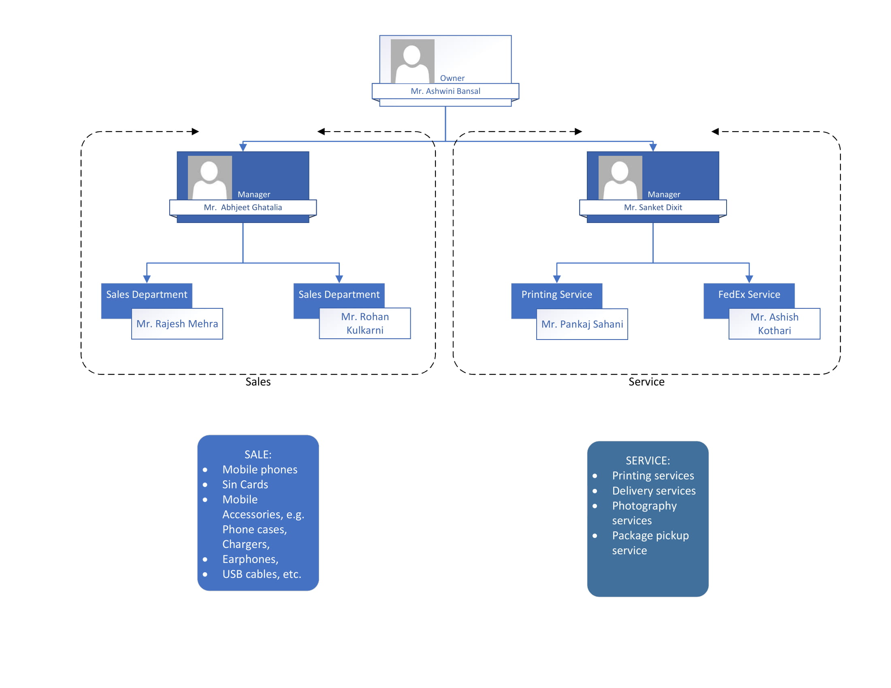

**Figure 1: Organizational Chart – Business Unit**

The existing system is traditional and the data is usually stored in excel sheets due to which performing analysis on the data is restricted, which basically limits the scope of the business. Due to lack of data support, the workforce flow has low efficiency. The company doesn’t have its official website for customers to place order and request for more specific customer service. Moreover, without online platform, the business can’t promote itself on digital marketing, which limits its capability for reaching potential customers. The future organization chart is shown below in the figure.

**2.2 System Workflow Diagram**

The diagram below shows workflow diagram of the existing system for the company.

|  |
| --- |
|  |

**Figure 3: Existing System Workflow Diagram**

The diagram below shows workflow diagram of the new system.

|  |
| --- |
|  |

**Figure 4: New System Workflow Diagram**

1. **System Request – E-commerce website.**

|  |
| --- |
| **System Request** |
| **Project Sponsor:**  Mr. Ashwini Bansal, owner of the Chandigarh Trading LLT is going to sponsor the project. |
| **Business need:**   * This project is initiated to build an efficient e-commerce website to streamline customer experience to extend their reach. * To serve existing customers and form new online customer base using internet to boost sales. * To build a secured payment portal to protect the integrity of the user’ data. * To store customer data and get user feedback and analyze their behavior to derive insights and improve business. * To increase the conversion rate as customers will purchase products online from the online system, rather than visiting the store or buying the product by calling the vendor. * To let customers access the online platform and purchase products 24/7 and not just during regular store hours. * To reinforce product range and help product manufacturers to sell their products online and earn a great deal of profits. |
| **Business Requirements:**   * To develop a well-organized online web application platform to offer all the resources and services to the users. * Design a systematic front end home page in the website for the customers. * A website where customers can create their personal accounts to purchase products of their choice. * The website will comprise of all the information related to the products as well as deals offered by the business and user data in form of a database. * To offer shopping cart feature where existing customers and guest customers can store their products and look for other products to add and then proceed with the payment checkout. |
| * The website will have a hyperlink to track FedEx consignments along with shipment details which will be available for the users to access information. * Integrating different payment gateways to offer wide array of options to make payments for the selected products. |
| **Business Value:**  We expect that Online web platform will increase sales by allowing existing customers to purchase mobile phones, cellphone accessories and sim cards and also attract new users who are inclined to buy those products. The expected annual revenue should get a boost by a margin of 15-20%. We expect that enhanced user experience will reduce the number of complaints from the customers as most of the complaints registered are related to product availability. Intangible benefits like enhanced sales forecasting, product tracking, customer satisfaction and feedback would help in increasing the brand value of the company. A new source of income can be expected from online product offers, discounts and e-gift cards.  Conservative Estimates of the tangible value include the following:   * 20% more in sales from Mobile phones, Cellphone accessories on website and instore purchases. * 10% more in sales from stationary products, sim cards available on website and instore purchases. |
| **Special Issues or Constraints:**   * The system must go live by last week of December 2019 so that users can access the website from the start of next year. * The company wants to offer all possible products on the online platform to stay competitive in e-commerce. |

1. **Feasibility Assessment**

**4.1 Technical Feasibility**

|  |  |
| --- | --- |
| **Technical Feasibility:** Do we have the resources in our company to build this system? | |
| **Familiarity with the business application area:**   * When users and analysts are unfamiliar with the website, then it creates misunderstandings between them and there are greater risks in the system when performance gets affected. | **Familiarity with the technology:**   * When a system uses a website that has never been used before in this company, there is a good chance of major problems leading to greater risks and delays. |
| **Size of the project:**   * Greater the project, greater the risks | **Compatibility with the existing system:**   * New website should completely replace the existing system. |

**Familiarity with the business application area:**

The online website will be a modern method to do business. Although the user and the organization will be new and unfamiliar with the website, it will contribute to the business as the website development and maintenance cost will be considered negligible compared to the value it will provide to the organization. There are major benefits to build a website for the business as it will allow the business to expand its reach to the customers. In the current/traditional system the customers must be present in order to purchase anything from the company while the new system allows customer to access or purchase at anytime and anywhere.

**Lack of Familiarity with the technology**:

The website will be completely new for the organization, but the employees in the organization and their majority of customers are young, along with that the website developed will be user-friendly. When asked about the website, the customers, owner and the employees gave a positive response for the development of the website. Therefore, it should be easy for the organization to adapt to the new change.

**Project Size:**

The website developed will primarily focus of attracting the customers from the internet and hence it should be attractive and user-friendly. The size of the project mainly depends on the website and the functionalities. The normal duration of the project is about two and a half to three months.

**Compatibility with the existing system:**

There is no online application or website that currently exists and hence it can be concluded that there is no existing system. The currently existing system is normal traditional system wherein the customer walks in and purchases the items and the orders are taken through the phone-calls.

**4.2 Economic Feasibility**

|  |  |
| --- | --- |
| **Economic Feasibility:** Financial opportunities and risks in the project can be understood through this analysis. | |
| **Development Costs** | **Operating Costs** |
| **Tangible benefits** | **Intangible benefits and costs** |

**Development Cost:**

* Cost for developing a website.
* Cost for hosting a website.
* Cost for training the employees.
* Cost for creation of a database.
* Additional Functionalities will be a factor to increase the cost.
* Cost for setting up the security of the website.

**Operating Cost:**

* Website’s Operating Cost.
* Cost for operating the database.
* Cost for hosting the website annually.
* Cost for maintaining the website and database.
* Additional cost for any unpredicted failure of a website.

**Tangible Benefits:**

* Improved process efficiency.
* Revenue generated from the ads displayed on the website.
* Enhanced speed and accuracy.
* Automation of process.
* Better Productivity.
* Lowering the cost of employment.

**Intangible Benefits:**

* Improved customer experience.
* Saves time duration.
* Better business coverage.
* Enhanced Sales Forecasting.
* Increase in value of the organization.
  1. **Organizational Feasibility**

|  |  |
| --- | --- |
| **Organizational Feasibility:** The acceptability of the system in an organization and its incorporation into operations. | |
| **Strategic Alignment:** | **Project Champion** |
| **Organization and Management Support** | **System Users** |

**Strategic Alignment:**

The project aims to develop a website so that the local business can make use of the technology to increase revenue. The main objective of the website is to allow the customers to access the services as per their needs and make it user-friendly. It will ultimately result in reinforcing the customer base as the website will attract new customers and incline their interest in purchasing products on the online platform. The user can access the services with ease and all these factors will add business value to the organization. Entire process of ordering phones and accessories will be automated and hence it will save a lot of time and effort that is needed in the traditional method.

**Evaluation of the effect on stakeholders:**

**Project champion**:

The project champion will identify the project’s strategic goals and ensure that every member of the team has equal contribution so that the final outcome becomes a success. He is responsible for identifying the tasks and allocating them accordingly. The project champion will ensure to eliminate all the obstacles, motivate the team members and analyze the best practices used to incorporate in the project.

**Organization and Management Support**:

The organization and management is mainly referred to the higher officials that make decisions for the project. They should be aware of the investment of funds and resources that were decided during the planning phase and it is their responsibility to provide it to the IT team. One of their main goals is to select the project that will provide high returns and value to the organizations.

**System Users**:

The users are the one who will ultimately use and operate the product and hence their involvement is critical. They should clearly define their needs and give their feedback on almost every stage of the project development.

1. **Cost Benefit Analysis**

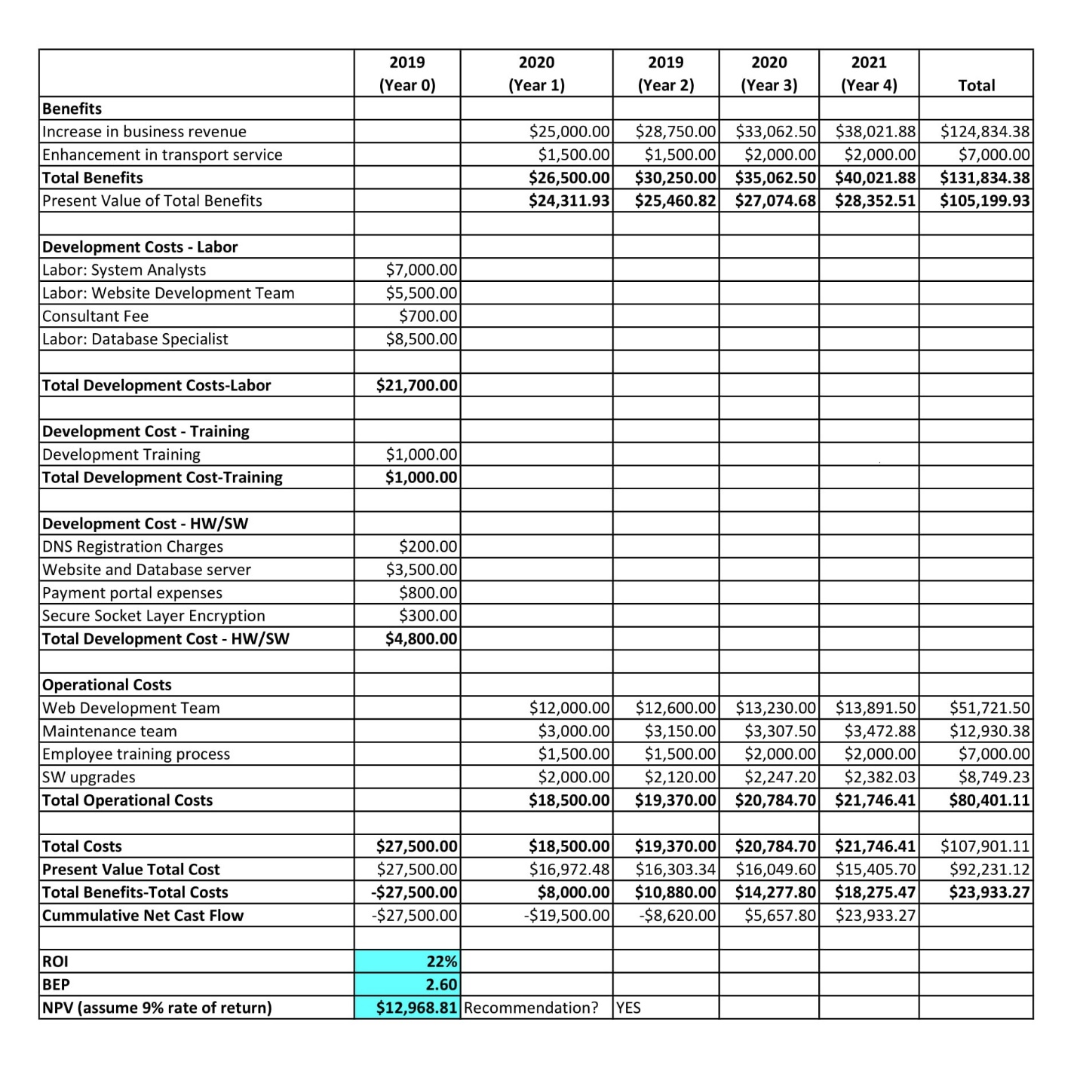

**Figure 5: Cost benefit Analysis**

1. **Project Work Plan**

**6.1 Planning Phase**

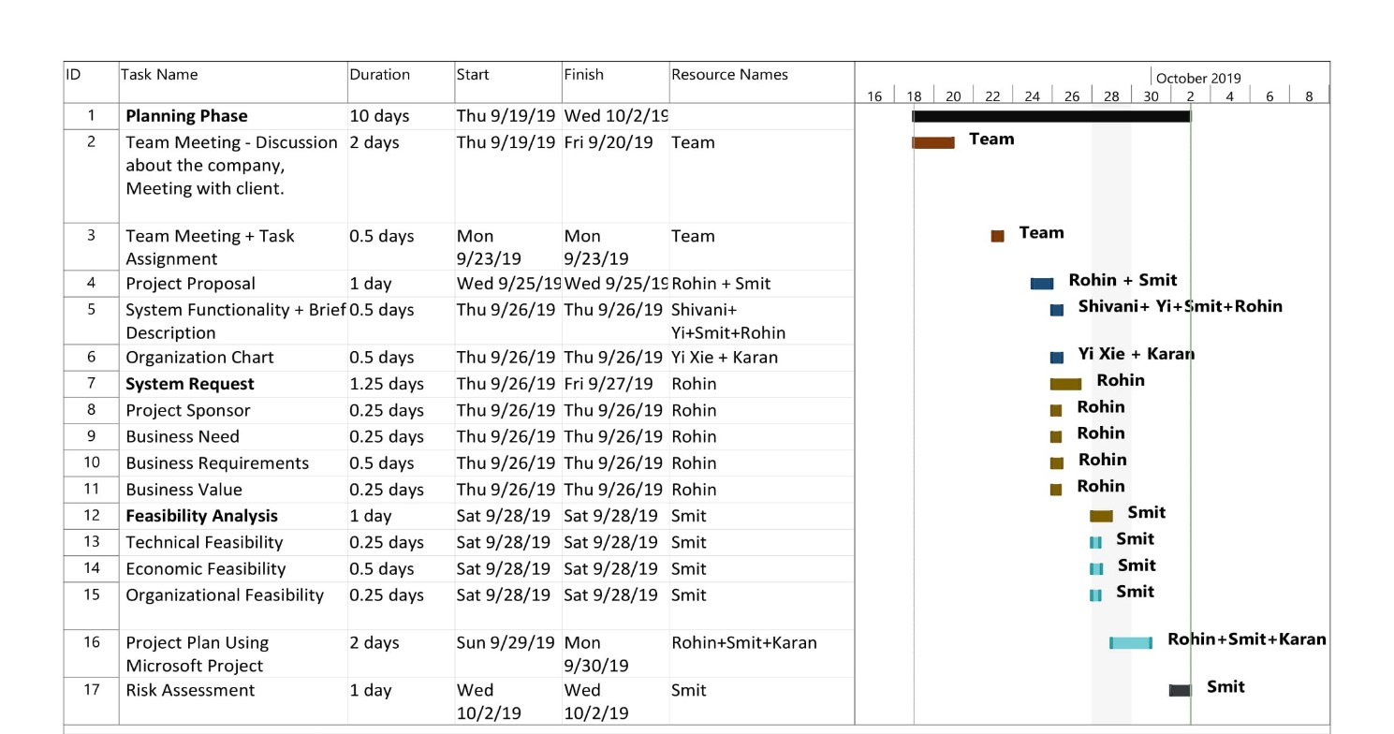The planning phase is the first phase in initiation of a project to design a system. In the planning phase we comprehended that why do we have to build this system? and how to initiate and setup the project? The deliverables of this phase include System Request Document, Feasibility Study, Project Work Plan and Risk Assessment. The image below is the project work plan we created using Microsoft project for the Planning phase of the system.

**Figure 6: Project Work Plan -Planning Phase**

**6.2 Analysis Phase**

In the analysis phase we came to know that understanding requirements is an essential step in the process. Here we asked the questions what should be deliver in the project? And how can we find new ways of building a system. The deliverables of this phase include Requirements Identification, Use Case Analysis, Developing Process Models and data models and building a revised project work plan for this phase. The image below is the project work plan we created using Microsoft project for the Analysis phase of the system.

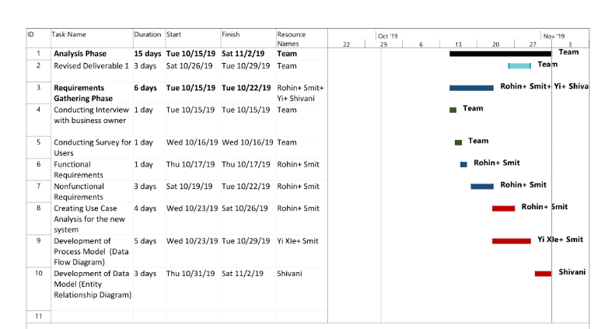

**Figure 7: Project Work Plan - Analysis phase**

**6.3 Design Phase**

In this Phase we understood how system will work exactly. We learnt the prime task of moving from old system to new system. The image below is the project work plan we created using Microsoft project for the Design phase of the system.

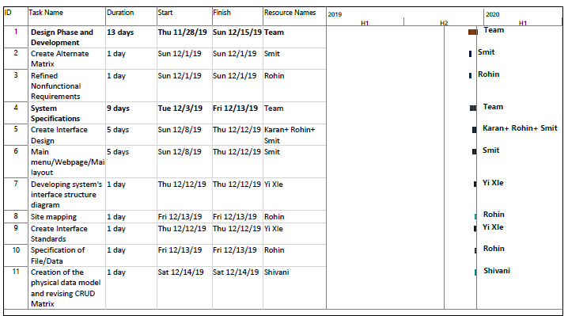

**Figure 8: Project Work Plan – Design Phase**

1. **Risk Assessment**

|  |
| --- |
| **Risk 1:** The website is prone to phishing and malware attacks from all over the internet. |
| **Likelihood of risk:**  Moderate, as the security of the website will be implemented step by step and in a proper manner. The website will be completely secured, and various measures will be taken to ensure the protection of the user’s data by using encryption process. |
| **Potential impact on the project:**  If the website is compromised, then the entire system or business will be in danger. The user’s data, entire process and the business value of the organization is affected. |
| **Ways to address this risk:**   * The website should have a secured database. * Loopholes in the codes must be prevented through some key measures. * The website should not take any file or document type of input from any user. * Various measures should be taken from time-to-time to keep the website updated. |
| **Risk 2:** The faults and glitches on the website that can affect the process of ordering or payment. |
| **Likelihood of risk:**  Not likely, as the entire website will be developed without any loopholes in the code. Along with that the website will be tested several times before it runs for the business. |
| **Potential impact on the project:**  The faults and glitches on the web are common issues and it can either lose the trust of the customers or act as a deterrent. Secondly it will have a tremendous negative impact on the business value of the organization. |
| **Ways to address this risk:**   * Testing should be done in every stage of the development. * The code of the website should be clear and flawless. * The risk should be determined at the earlier stages and proper counter-measures should be implemented. * The backup team should be available in case of any issues faced on the website. |
| **Risk 3:** The Website may fail to perform efficiently due to overload. |
| **Likelihood of risk:**  Moderate , as the number of users visiting the website can affect the performance of the website, it can cause serious trouble to the customers. |
| **Potential impact on the project:**  If the website fails to perform under high traffic, the customers will be forced to leave the website and it will have a negative impact on the business of the organization. |
| **Ways to address this risk:**   * The website should be tested meticulously. * The maintenance of the website should be done regularly. * The website should be equipped with enough servers to handle huge number of users at a single point of time. * Updates should be deployed regularly. * Estimation should be used to identify and predict the number of users and accordingly different servers must be employed. |

**Analysis Phase: Deliverable 2**

1. **Requirements Definition**

**8.1 Functional Requirements**

1. **Creating and Accessing the user’s Account**

* The website will create account for the user and allow the user to access the account via login credentials.
* The website will allow user to edit his account.
* The website will allow the user to add the product as their favorite or in the shopping cart.
* The website will allow the user to enter and save their credit card details for payment.
* The website will allow the user to check their order history.

1. **Searching Product and its Details**

* The website allows the user to search the relevant product through keywords.
* The user will have access to product details, product images and reviews.
* The website will suggest relevant accessories for the product which the user wants to purchase.
* The website will allow the user to write a review about the product only after its purchase.
* The website will send a notification by email when the user’s preferred product is available for purchase and gets restocked.
* The website will filter all the products that are currently out of stock from the search results for the user.
* The website will display estimated delivery date and charges to the user.

1. **Buying and Returning/Cancelling the product**

* Once the users wishes to buy the product, the system will redirect the user to the payment gateway.
* The website will allow the user to choose different payment methods. Example: Cash on delivery, Credit card payment, debit card.
* The website will allow the users to modify or add items in their shopping cart before checkout process.
* After the payment is completed, the website will enable the user to track their product.
* The website will send the confirmation to the user through email and messages
* If the user wish to cancel the purchase, then the website will allow the user to cancel the order.
* If the product is received by the user and they wishes to return it, then the website will check the return duration and process the user’s request accordingly.

1. **Customer Service**

* The website will enable the user to initiate live chat with the representative for solving their queries.
* The website will provide customer service by offering multiple mediums such as email communication and phone calls.
* The website will enable the user to provide feedback for the overall customer service.

**28.2 Non-Functional Requirements**

1. **Operational Requirements**

* The website will be compatible on various web browsers.
* The website will be compatible and responsive with different screen size.
* The website will be able to replace existing system.
* The user should get access to the online platform from any location through internet.

1. **Performance Requirements**

* The website should be online 24 hours a day on the internet.
* The website should support and manage huge amount of traffic efficiently without any performance degradations.
* The loading time of the website should not exceed more than 1 ms.
* The website should ensure that the average response time for logging into account using username and password should not be more than 4 seconds.
* The website should permit a maximum downtime of 5 hours for any upgrade or server failure.

1. **Security Requirements**

* The website should provide privacy to the user by protecting their personal information using data encryption.
* The website should be equipped with the web application firewall to shield from malware, viruses and trojan horse and worm attacks.
* A secure server will be implemented by the website to secure the payment details of the user and ensure its confidentiality.

1. **Cultural and Political Requirements**

* The website should automatically adapt itself to the language used by the respective machine.
* The website will allow billing system to generate invoice in multiple currencies accordingly.

1. **Use case Analysis**

|  |  |  |  |  |  |  |
| --- | --- | --- | --- | --- | --- | --- |
| **Use Case Name:** Creation of the account | | | **ID:** 1 | | **Priority:** High | |
| **Brief Description:** This process will allow the user to create an account on the website and become a registered user. | | | | | | |
| **Actor:** User | | | | | | |
| **Trigger:** User chooses to create an account to purchase products on the website.  **Type 🗹 External 🞎 Temporal** | | | | | | |
| **Preconditions:**   1. The user should request for creation of a new account. | | | | | | |
| **Normal Course (Creation of the account):**   1. The user enters the user account information and the website saves the details to enable registration. 2. The website authenticates the user account details. 3. The website informs the user that account has been created. 4. The website sends e-mail to the user for account creation confirmation. | | | | **Information for Steps**  ← Personal information, user credentials  ← User Account Data  → Account creation Notification  → E-mail | | |
| **Alternative Course(Creation of the Account)**  The user inputs invalid information and the website denies access for the account creation.   1. The user enters invalid user account information. 2. The website determines that user has entered invalid account data. 3. The website notifies the user to re-enter valid account information for successful login. 4. The user re-enters valid account information and the website verifies it. 5. If the data entered by the user is correct, then the website will store the information in its user account database. 6. If invalid data is entered again then the whole process repeats itself until the user enters valid information to create the account on the website.   The user cancels the request of creating a new account and the further process is rejected.   1. The user chooses to cancel the registration for creating a new account. 2. The website cancels the registration and redirects the user to the home page to access the products. | | | | **Information for Steps**  ← Personal information, user credentials  ← Personal information, user credentials  → User Account Data | | |
| **Postconditions:**   1. The user enters credentials and gets logged into the account to purchase products. 2. The user has access to the website to view the product and its description as a non-registered user. | | | | | | |
| **Exceptions:**   1. The user verification fails due to bad email network connectivity. 2. The user verification fails due to Unstable internet connectivity. 3. The website crashes during the process of creating the account. | | | | | | |
| **Summary:**  **Inputs Source Outputs Destination** | | | | | | |
| Personal information, user credentials  User Account Data | User  User | Account Creation Notifica-  Tion  E-mail  User Account Data | | | | User  User  User Account Database |

|  |  |  |  |  |  |  |  |
| --- | --- | --- | --- | --- | --- | --- | --- |
| **Use Case Name:** Searching and adding products to cart. | | | **ID:** 2 | | | **Priority:** High | |
| **Brief Description:** The user enters the product parameters to search and add the preferred product to cart on the website. | | | | | | | |
| **Actor:** User | | | | | | | |
| **Trigger:** User wishes to search for products and place an order for purchase.  **Type 🗹 External 🞎 Temporal** | | | | | | | |
| **Preconditions:**   1. User is logged into the personal account for adding the product to shopping cart. 2. User must be familiar with the product they want to search on the website. | | | | | | | |
| **Normal Course**   1. The user searches for a product on the home page of the website. 2. The website displays a list of products from the respective category. 3. The user selects the preferred product from the list of products 4. The website displays the products description, product availability and its purchase price. 5. The user selects the product and adds it to the shopping cart. | | | | **Information for Steps**  ← Product Parameters  → List of products  → Product Description, Availability, Price | | | |
| **Alternative Course(s):**  The product searched by the user goes out of stock and is not available for purchase.   1. The user searches for a certain product for the purchase. 2. The website checks for the product in its database and notifies the user about its unavailability 3. The user searches for another product for the purchase. 4. The use case returns to normal course step 4 . | | | | | **Information for Steps**  ← Product Parameters  → Website Notification  ← Product Parameters | | |
| **Postconditions:**   1. The website must save the products added in the shopping cart when the user is logged out of the account. | | | | | | | |
| **Exceptions:** None | | | | | | | |
| **Summary:**  **Inputs Source Outputs Destination** | | | | | | | |
| Product Parameters | User | List of products  Product Description, Product  Availability, Price  Website Notification | | | | | Product Database  Product Database  User |

|  |  |  |  |  |  |  |  |
| --- | --- | --- | --- | --- | --- | --- | --- |
| **Use Case Name:** Placing Order | | | **ID:** 3 | | | **Priority:** High | |
| **Brief Description:** The order process will allow the user to purchase a product on the website. | | | | | | | |
| **Actor:** User | | | | | | | |
| **Trigger:** User chooses to order a product from the website after successful registration.  **Type 🗹 External 🞎 Temporal** | | | | | | | |
| **Preconditions:**   1. User should be logged into the account. 2. User must select the product for the purchase and add it to the shopping cart. | | | | | | | |
| **Normal Course**   1. The user reviews the product to be ordered in the shopping cart. 2. The website will provide the cost of the product and its description and prompt the user to confirm the order. 3. The user clicks on place order link to initiate the purchase for the product. 4. The website requests the user to input credit card information to initiate payment. 5. The user enters the valid credit card information and selects make payment option. 6. The website will verify the information entered by the user. 7. The website will display the confirmed order and generate order details and order-id for the user. 8. The website prompts the user by generating successful order notification. 9. The website sends a confirmation email to the user with an invoice for the purchased product. | | | | | **Information for Steps**  ← Product Review  → Product cost, Product Description  → User credit card information  ← User credit card information  → Order Details, Order-Id  → Website Notification  → Confirmation Email, Invoice | | |
| **Alternative Course(s):**   1. The user will remove the product from the cart before the purchase. 2. The website will cancel the order process with the order not being saved and the use case ends. | | | | **Information for Steps**  ← Product Removal  → Order Cancellation. | | | |
| **Postconditions:**   1. The order will be placed successfully. 2. A confirmation e-mail comprising of order details is sent to the user. | | | | | | | |
| **Exceptions:**   1. The product to be ordered goes out of stock and is not available for the purchase. 2. The Payment gateway associated with the customers bank crashes due to server issues. | | | | | | | |
| **Summary:**  **Inputs Source Outputs Destination** | | | | | | | |
| Product Review  User credit card information  Product Removal | User  User  User | Order Details, Order-Id  Website Notification  Confirmation E-mail, Invoice | | | | | User, Products Database  User  User |

|  |  |  |  |  |  |  |
| --- | --- | --- | --- | --- | --- | --- |
| **Use Case Name:** Cancelling Order Process | | | **ID:** 4 | | **Priority:** High | |
| **Brief Description:** This process will allow the user to place an order in the website. | | | | | | |
| **Actor:** User | | | | | | |
| **Trigger:** User wants to cancel the order.  **Type 🗹 External 🞎 Temporal** | | | | | | |
| **Preconditions:**  1. User must place an order through the website to cancel it.  2. The order placed must be in the cancellation period before the shipment is processed. | | | | | | |
| **Normal Course**   1. User will select the product whose order needs to be canceled from list of ordered products. 2. The user will verify the product to be cancelled and check its order status. 3. The website will request confirmation of the order for cancellation 4. The user gives the confirmation to proceed to further for the cancellation process. 5. The website notifies the user that order has been successfully canceled. | | | | **Information for Steps**  ← Ordered product.  ← Product verification  ← Confirmation Request  ← Product Validation  → Order Cancellation | | |
| **Alternative Course(s):**   1. The user cancels the order by calling customer service. 2. The customer services asks for order-id of the product. 3. The user inputs order-id on the call 4. The customer verifies the ID and cancels the order | | | | **Information for Steps**  ← Order cancellation  ← Order-Id Request  ← Order-Id input  → Personal Details | | |
| **Postconditions:**   1. The order will get cancelled successfully. 2. The website will initiate refund for the product whose order is cancelled. | | | | | | |
| **Exceptions:**   1. If the user attempts to cancel the order after the shipment of the product, the system will not process the request to cancel it. 2. The account used by the user to order the product is no longer valid. 3. The product purchased by user is not accessible in the order inventory of the website. | | | | | | |
| **Summary:**  **Inputs Source Outputs Destination** | | | | | | |
| Ordered Product  Product Verification  Confirmation Request  Product Validation  Order Cancellation  Order-Id Request  Order-Id Input | Ordered product Database  User  Website  User  User  Customer Service  User | Order Display  Order Cancellation  Personal Details | | | | User  User  Customer Account Database |

|  |  |  |  |  |  |  |  |
| --- | --- | --- | --- | --- | --- | --- | --- |
| **Use Case Name:** Processing Payment for the product purchase | | | **ID:** 5 | | | **Priority:** High | |
| **Brief Description:** This process allows the customer to make a payment for the chosen product added in the shopping cart. | | | | | | | |
| **Actor:** User | | | | | | | |
| **Trigger:** User chooses to order a product from the website after successful registration.  **Type 🗹 External 🞎 Temporal** | | | | | | | |
| **Preconditions:**   1. The user must add the product in the shopping cart for the purchase. 2. The user must confirm if the payment portal of the respective bank is accessible to pay the amount. | | | | | | | |
| **Normal Course**  After the product selection, the user moves forward to the payment portal for purchasing the product.   1. The user confirms the product added in the shopping cart and then progresses further to the payment portal. 2. The website requests the user to choose the preferable payment option 3. The user chooses the payment method of their choice from different options like credit card, debit card, PayPal, e-commerce wallet 4. The user enter the payment details to proceed further. 5. The websites initiates a payment authorization request to the payment processor for further approval. 6. After authorization, the website proceeds with the payment and generates a confirmation ID for successful payment process. 7. The website will generate an invoice and initiate a payment confirmation on the registered email-id and mobile number of the user. | | | | | **Information for Steps**  ← Order Confirmation  → Payment Method Request  ← Payment Options  ← Payment Details  → Payment Authorization Request  → Payment Confirmation ID  → Payment Notification | | |
| **Alternative Course(s):**  The user enters invalid payment details and the websites denies successful payment for the purchasing the product.   * 1. The user enters invalid payment information for the product purchase.   2. The website prompts the user to re-enter the valid payment information.   3. The user enters the payment details for the website to validate further.   4. If the information entered is valid, then the use case returns to normal course step 5.   The user wants to purchase the product by selecting cash on delivery option.   * 1. The user chooses the cash on delivery payment method for the product purchase   2. The use case returns to normal course step 6. | | | | **Information for Steps**  ← Payment Information  ← Payment Information  ← Cash on delivery option | | | |
| **Postconditions:**   1. The customer will receive confirmation through email notification and messages. 2. The order is placed successfully and the user can save the payment details for next purchase or enter the details again for the new order. 3. The customer receives the product’s estimated delivery date and tracking number. | | | | | | | |
| **Exceptions:**   1. The payment is not processed due to invalid entry of payment details from user. 2. The Payment gateway associated with the customers bank crashes due to server issues. | | | | | | | |
| **Summary:**  **Inputs Source Outputs Destination** | | | | | | | |
| Order Confirmation  Payment Options  Payment Details  Payment Information  Cash on delivery option | User  User  User  User  User | Payment Method Request  Payment Authorization  Request  Payment Confirmation ID  Payment Notification | | | | | Website  Merchant payment Gateway  User  User |

**10. Process Models**

**10.1 Context Data Flow Diagram**

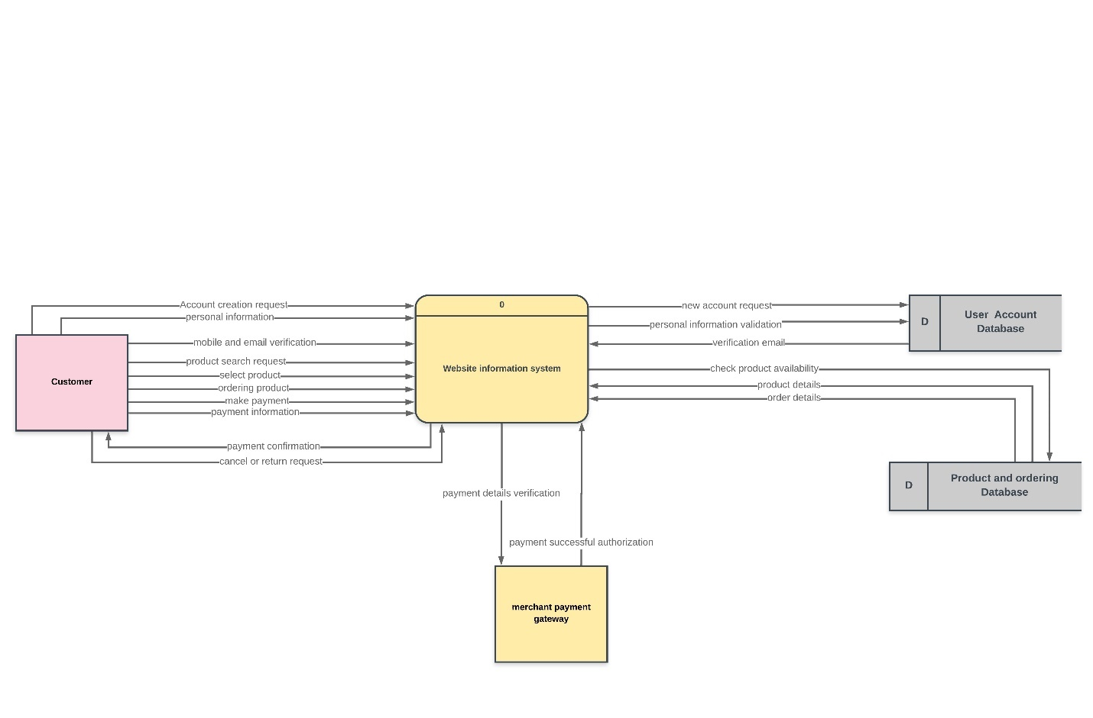

**Figure 9: Context Data Flow Diagram**

**10.2 Level 0 Data Flow Diagram**

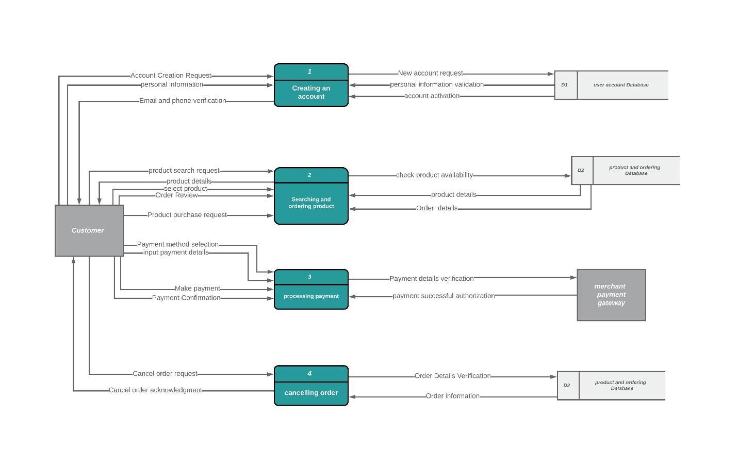

**Figure 10: Level 0 Data Flow Diagram**

**10.3 Level 1 Data Flow Diagram**

**a) Creation of an Account:-**

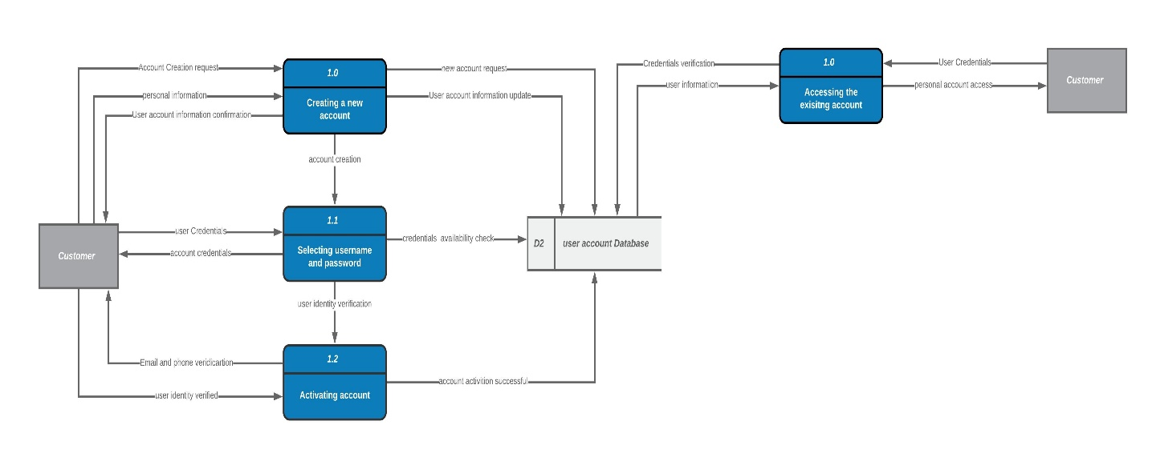

**Figure 11: Creation of an Account**

**b) Searching and Ordering the product:-**

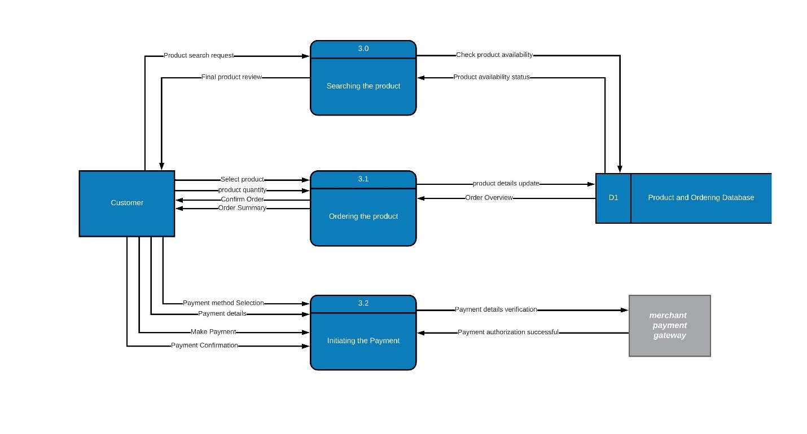

**Figure 12: Searching and Ordering the product**

**c) Cancelling Order Process:-**

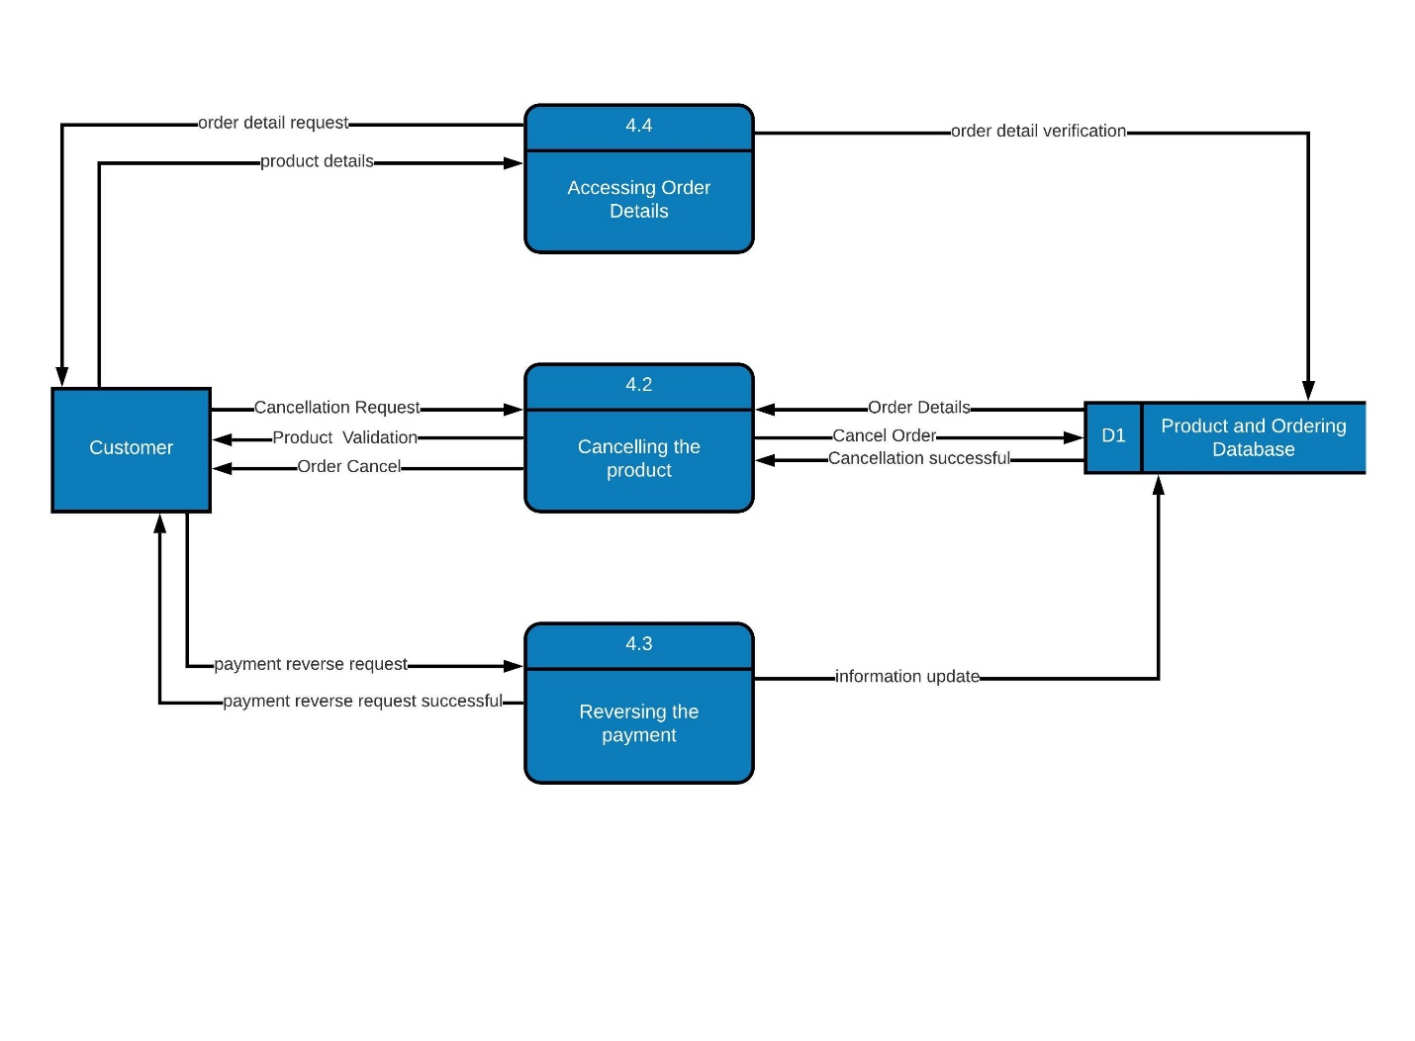

**Figure 13: Cancelling Order Process**

**10.4 Level 2 Data Flow Diagram**

**a) Searching and ordering Product:-**

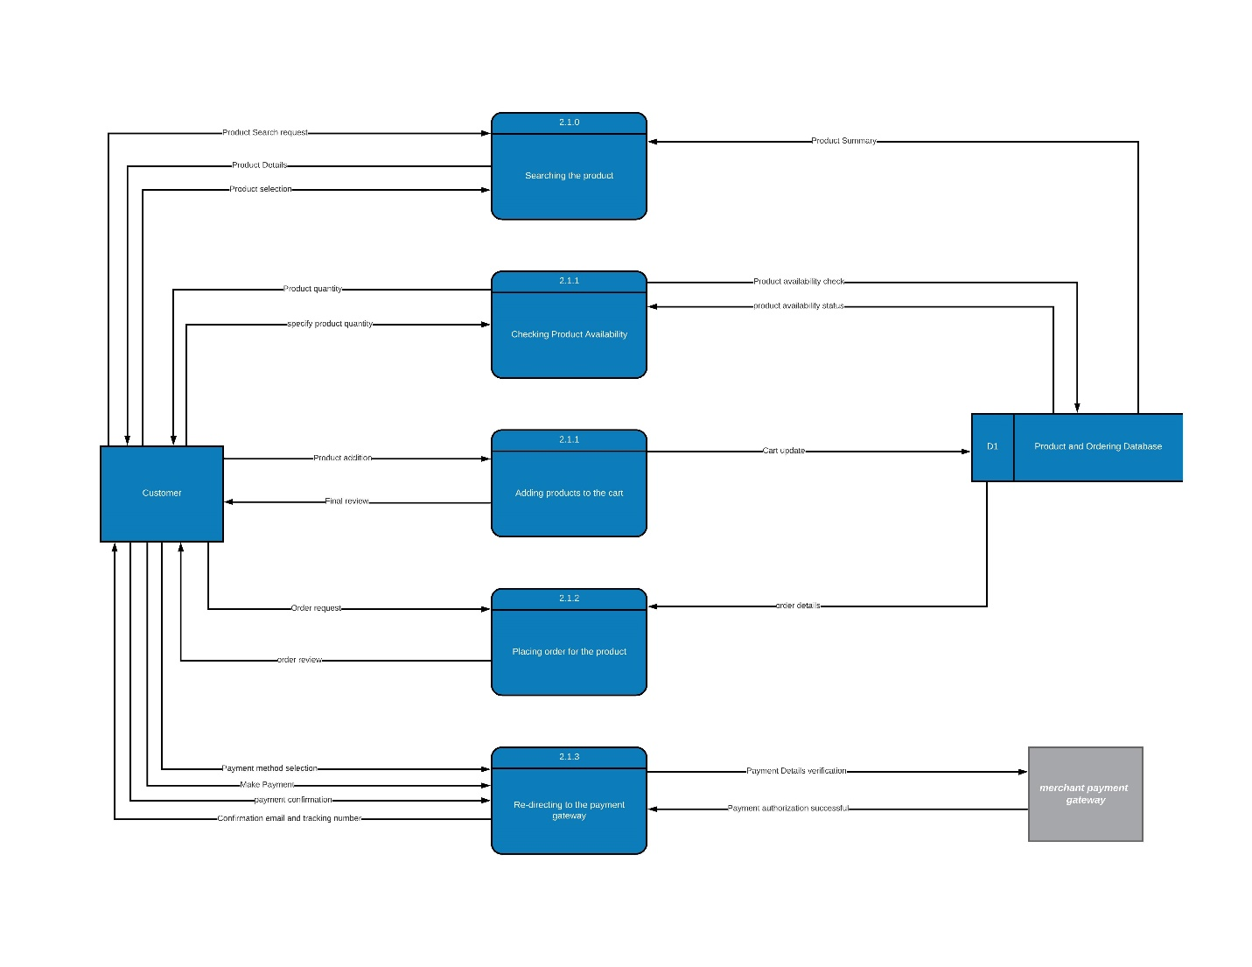

**Figure 14: Searching and ordering Product**

**11. Data Model – Entity Relationship Diagram**

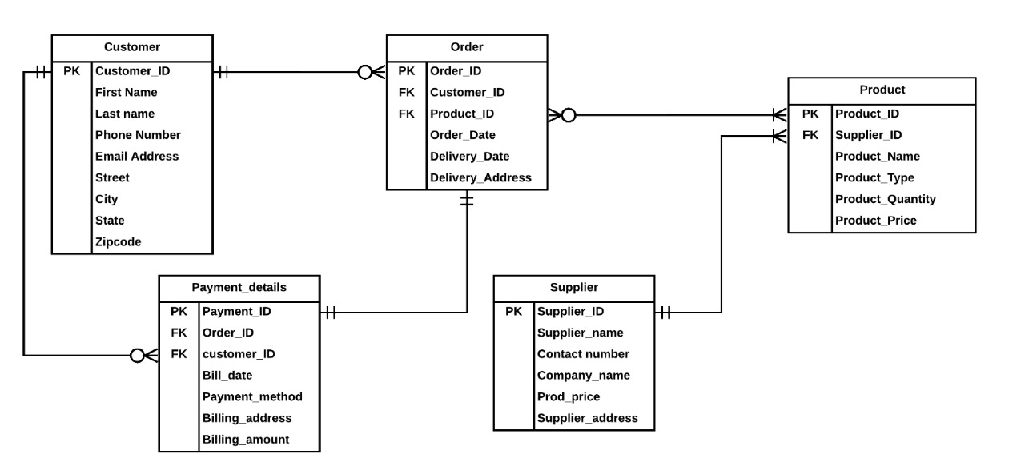

**Figure 15: Entity Relationship Diagram**

**12. CRUD Matrix**

|  |  |  |  |  |  |
| --- | --- | --- | --- | --- | --- |
|  | Account Creation | Searching and Adding products to the cart. | Placing Order | Cancelling Order | Payment Processing |
| **CUSTOMER** |  |  |  |  |  |
| Customer_ID | CR |  | R | R | R |
| first_name | CRU |  | R | R | R |
| Last_name | CRUD |  | R | R | R |
| Phone_number | CRU |  | R | R | R |
| email_address | CRU |  | R | R | R |
| street | CRU |  | R | R | R |
| city | CRU |  | R | R | R |
| state | CRU |  | R | R | R |
| zip code | CRU |  | R | R | R |
| **ORDER** |  |  |  |  |  |
| order_id |  |  | CR | RD | R |
| customer_id |  |  | R | R | R |
| product_id |  |  | R | R | R |
| Order_date |  |  | C | RD |  |
| delivery_date |  |  | C | RD |  |
| delivery_address |  |  | CRU | RD |  |
| **PRODUCT** |  |  |  |  |  |
| product_ID |  | CR | R | R | R |
|  | Account Creation | Searching and Adding products to the cart. | Placing Order | Cancelling Order | Payment Processing |
| product_name |  | CR | R | R | R |
| product_type |  | CR | R | R | R |
| product_quantity |  | CRU | RU | R | R |
| product_price |  | CR | R | R | R |
| **PAYMENT** |  |  |  |  |  |
| payment_id |  |  |  | RD | CR |
| order_id |  |  |  | RD | R |
| customer_id | R |  |  | R | R |
| payment_date |  |  |  | RD | CR |
| billing_address | R |  |  | RD | RU |
| Billing_amount |  |  |  | RD | CR |

**Design Phase: Deliverable 3**

**13. Alternative Matrix**

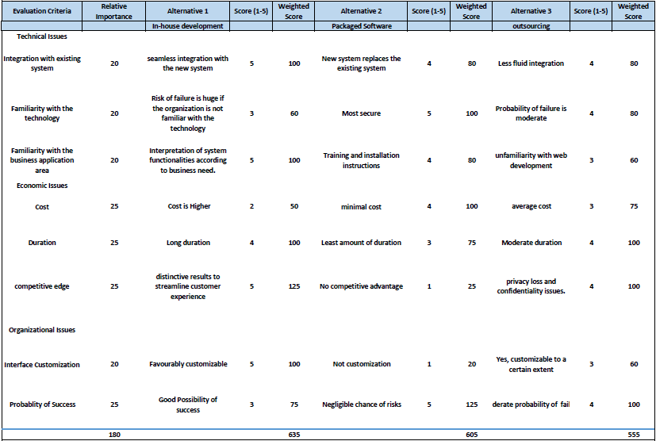

**14. Refined Non-Functional Requirements**

**1.1 Operational Requirements**

1. The website should be compatible with web browsers on Microsoft, IOS and Android operating systems.
2. The website must allow the user to filter and classify their products based on the brands, purchase prices and customer reviews.
3. The website should be accessible to the user from any location on Local area Network (LAN), wide area network (WAN) and private area network (PAN).
4. The website should demonstrate a responsive and compatible design of its layout according to the screen size as well as the screen resolution of the device i.e. Desktop Monitors, Laptops, Mobile Devices, Tablet Devices.
5. The website must be able to track customer preferences and their product buying patterns to derive insights by recommending their preferred products for the purchase.
6. The website should allow the customer access their product purchase history in the personal account.
7. The website should enable the customer to update their personal and payment information in the user account.
8. The website should allow the user to track their product after the online purchase with successful payment.

**1.2 Performance Requirements**

1. The website should be accessible to the users 24/7 on the world wide web.
2. The website must manage heavy amount of traffic from extensive users without any performance degradations for optimizing web performance
3. The website must be able to redirect the user from product purchase webpage to merchant payment gateway webpage with a response rate of 1ms to initiate the payment process.
4. The website should ensure that the average response time for logging into the user account must not exceed more than 2 seconds.
5. The website must permit a scheduled downtime of 5 hours in the off-peak hours for server failures and system upgrades.
6. The response time rate of loading a webpage must not exceed more than 1ms.
7. The website should be able to initiate and process the order successfully within 10 seconds

**1.3 Security Requirements**

1. The website should be equipped with web application firewall to shield user and product data from malicious viruses, malwares, trojan and worm attacks.
2. The website’s product information and customer data (user password encrypted) must be accessible only to system’s database administrator.
3. The website must employ a payment processor to secure and encrypt payment information to avoid credit card frauds and payment security breaches.
4. The website should ensure to perform automatic data backups to retrieve website and customer data and restore them after security breaches or virus attacks.
5. The website must authenticate the users by verifying their email address and phone number before registering them for the personal account.
6. The website will enable only registered customers to place an order or cancel it after the product purchase.

**1.4 Cultural and Political Requirements**

1. The website will automatically adapt itself to the language used by the respective machine.
2. The website will offer a feature to translate and change the language according to the customer’s preference and access the web content.
3. The website will enable the secured payment portal to generate invoice in multiple currencies across the global platform.
4. The website should be accessible to the customers with a certain vision impairment such that the website content must be displayed in a visible font.
5. The website should be accessible to the users all over United States for purchasing products.
6. The website must ensure to protect personal data, data integrity and privacy of the customer under United States Privacy Act.

**System Specification**

**15. System Interface Design**

**a) Main page**

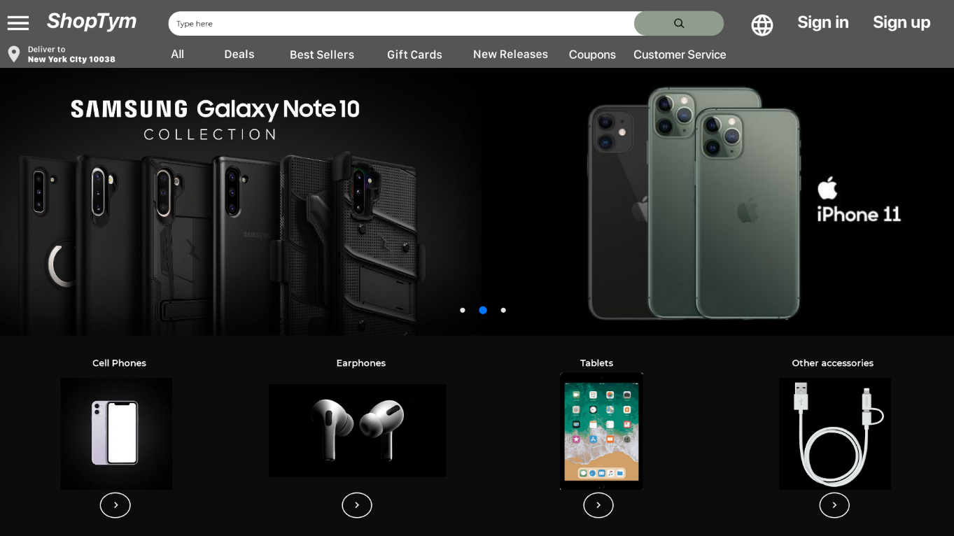

**b) Sign in page**

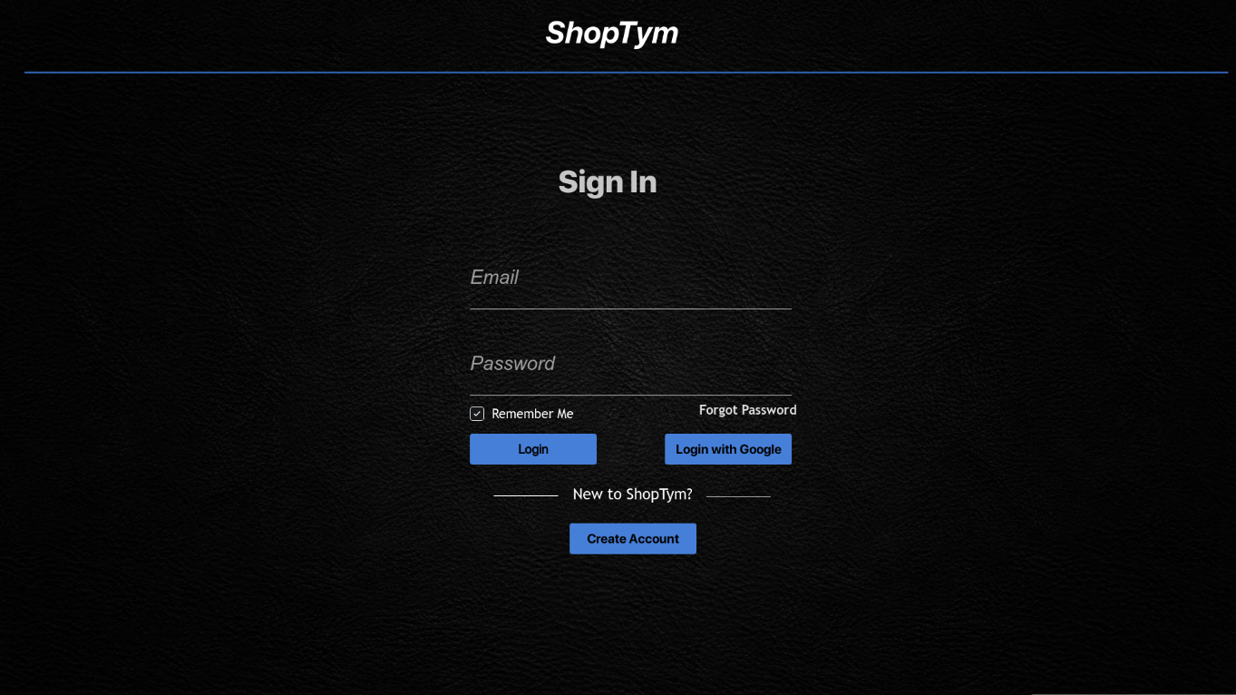

**c) Sign up page**

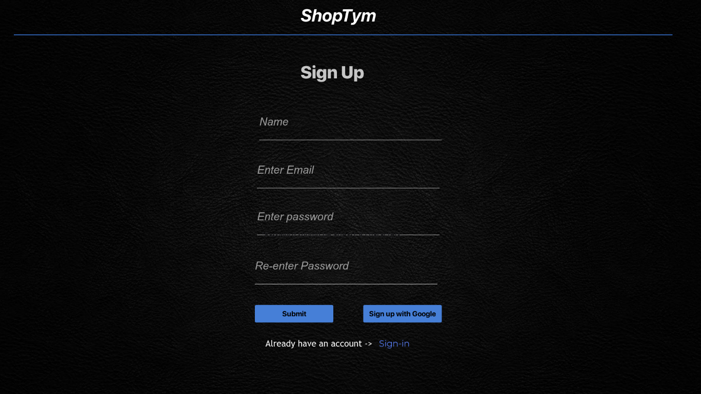

**c) Home page**

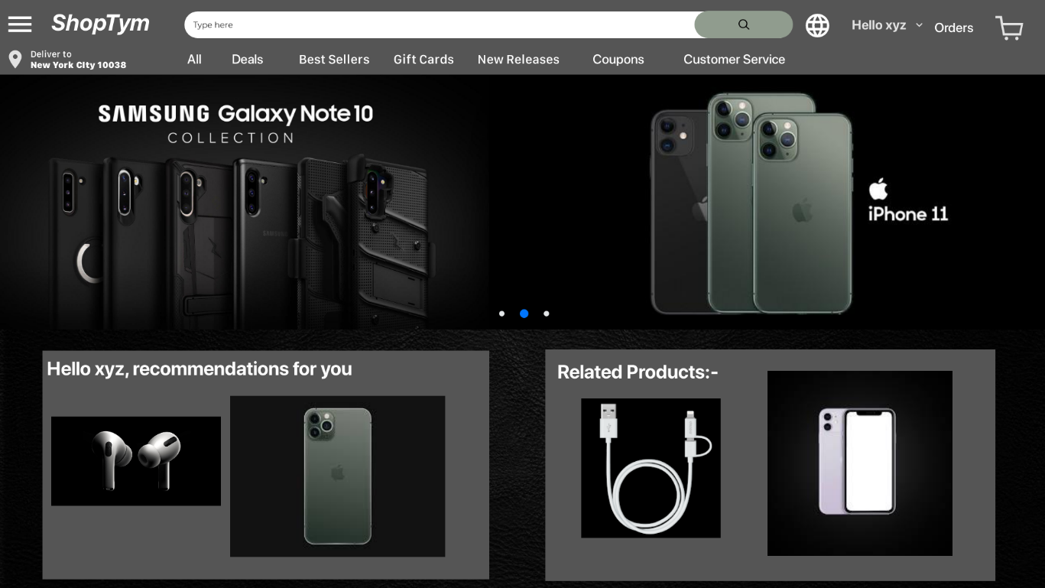

**d) Product List Page**

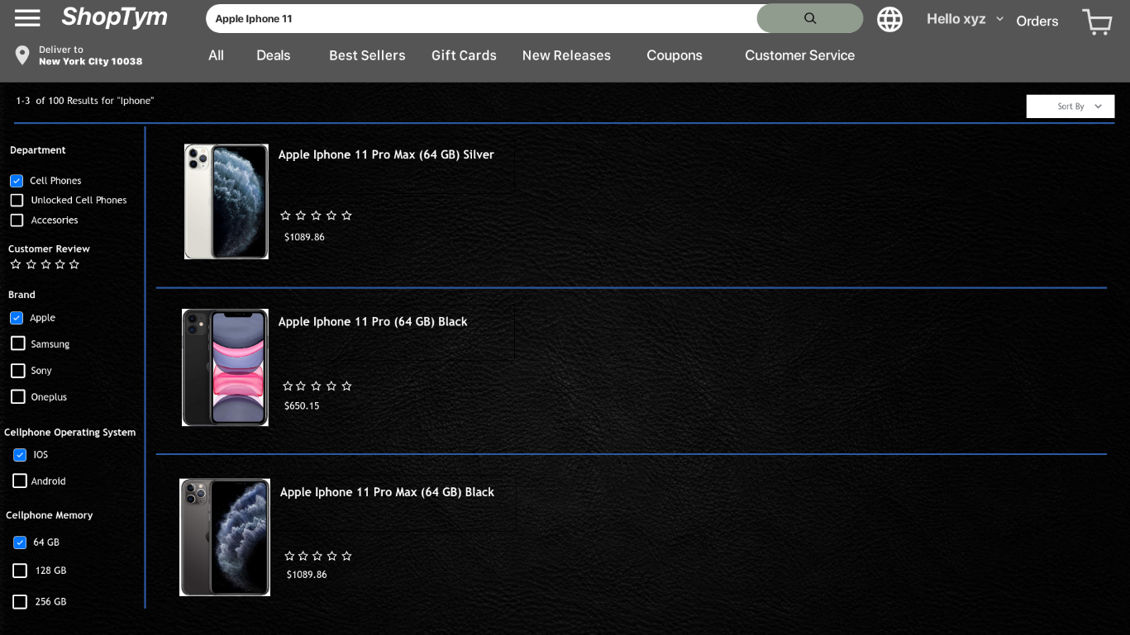

**e) Product Details page**

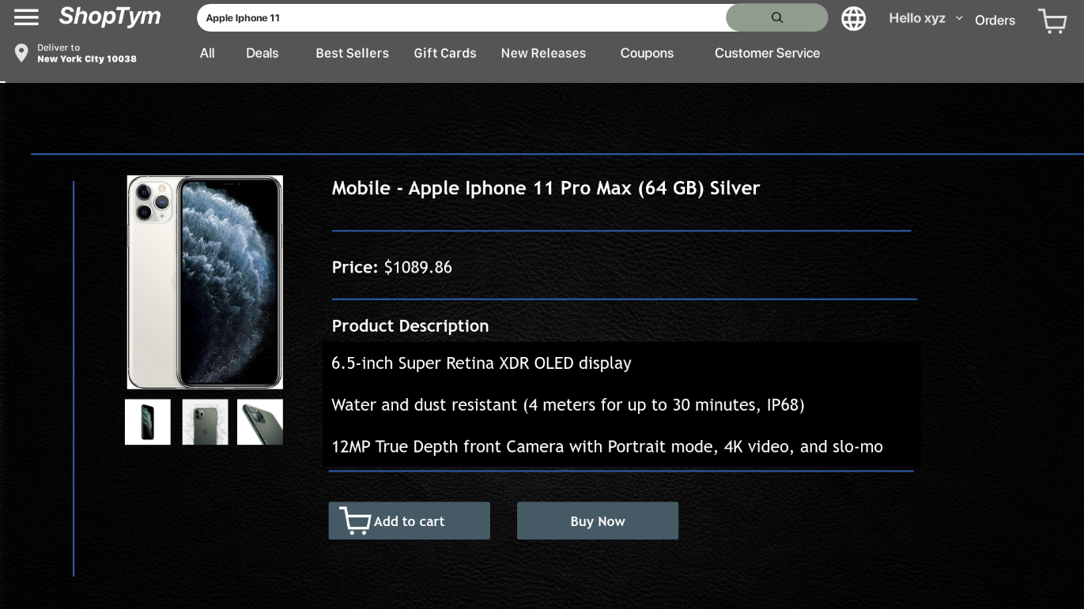

**f) Shopping Cart page**

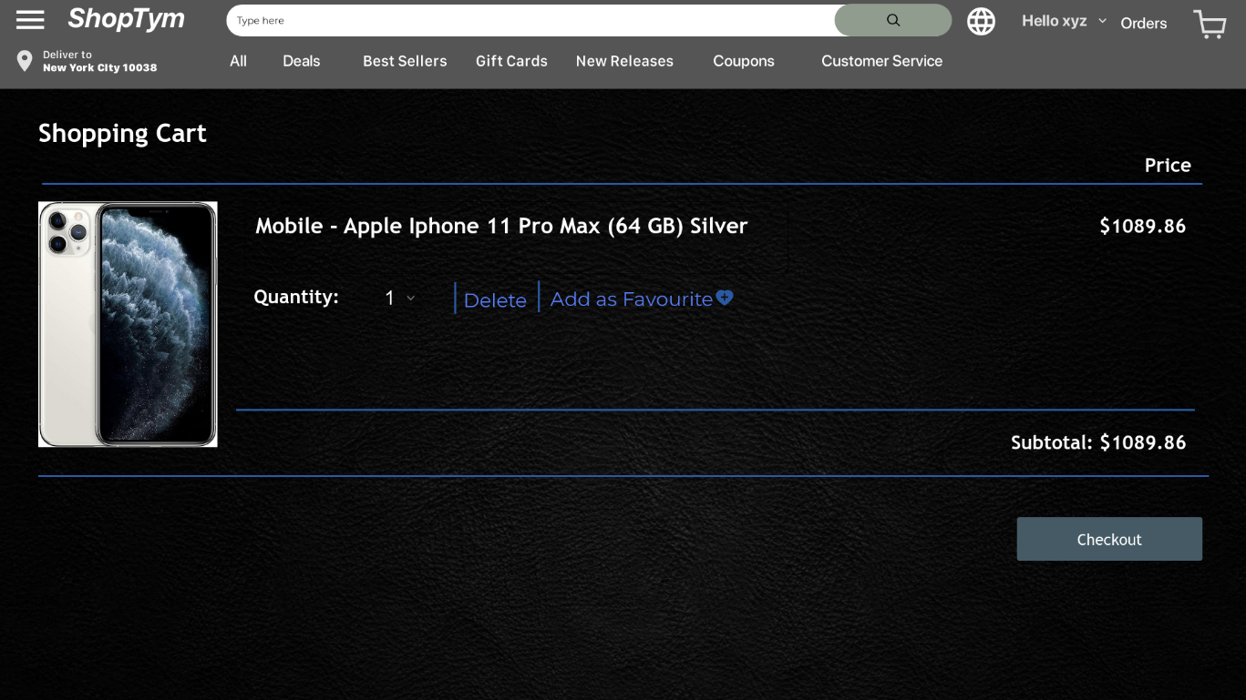

**g) Shipping Details Page**

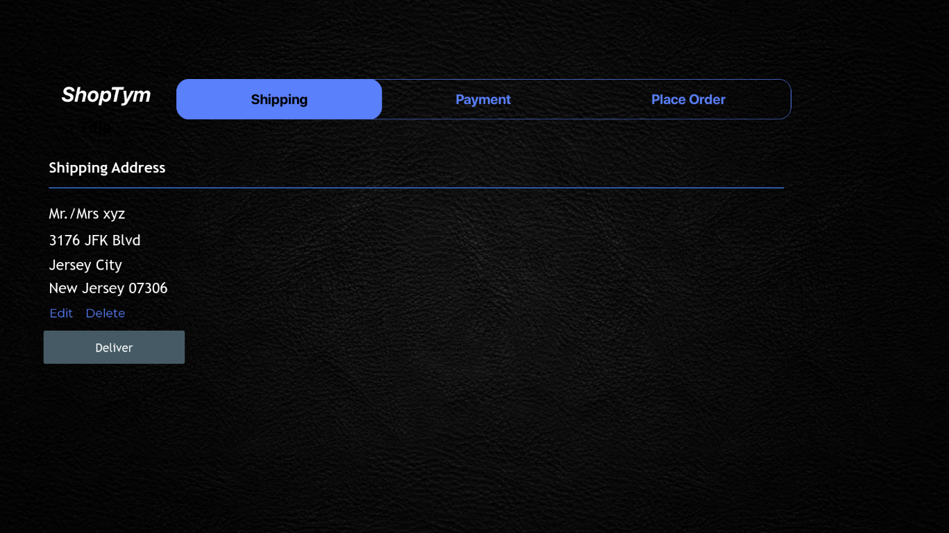

**h) Payment Details Page**

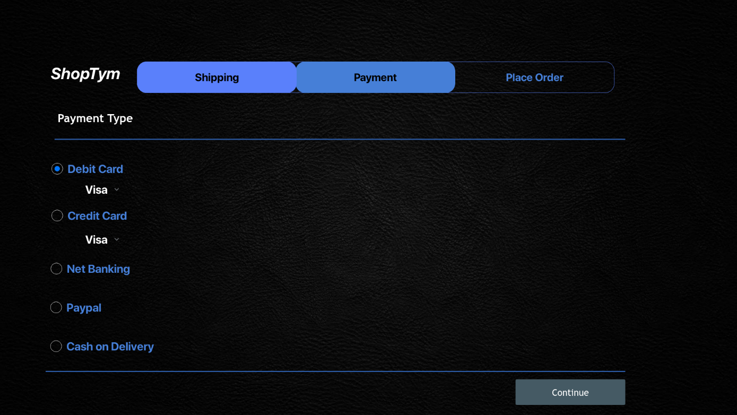

**i) Place Order page**

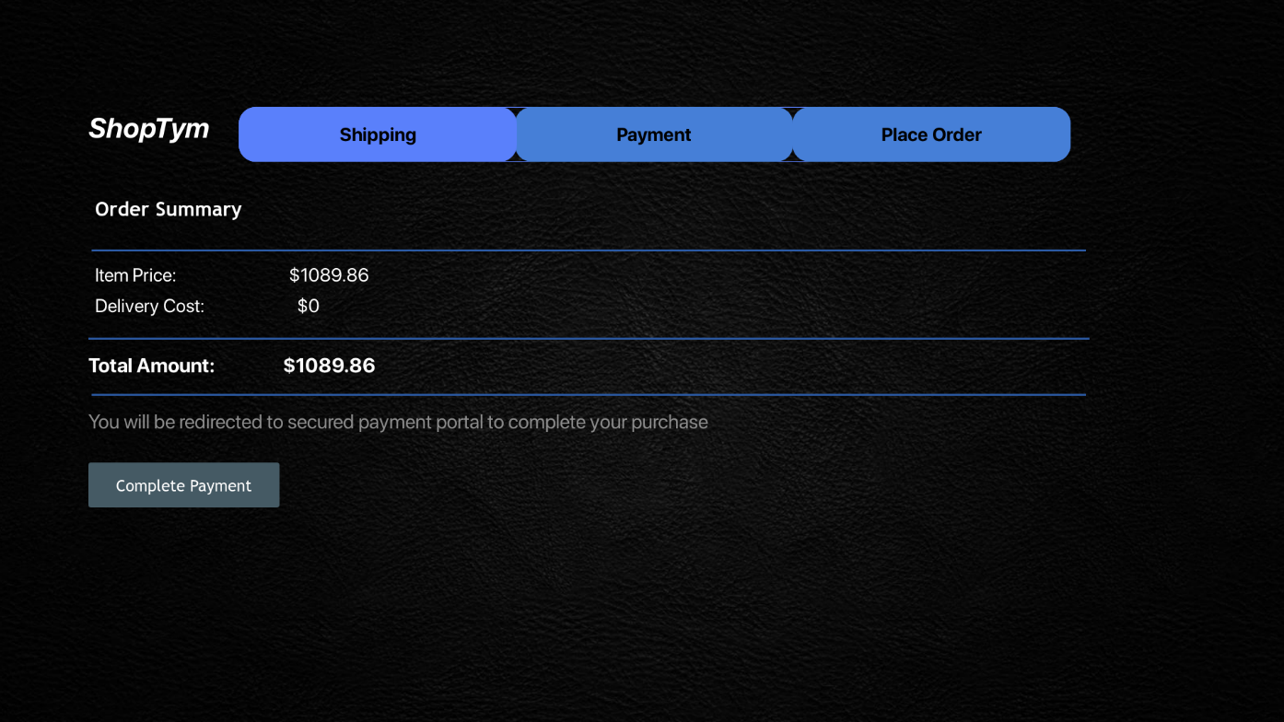

**j) Order Successful page**

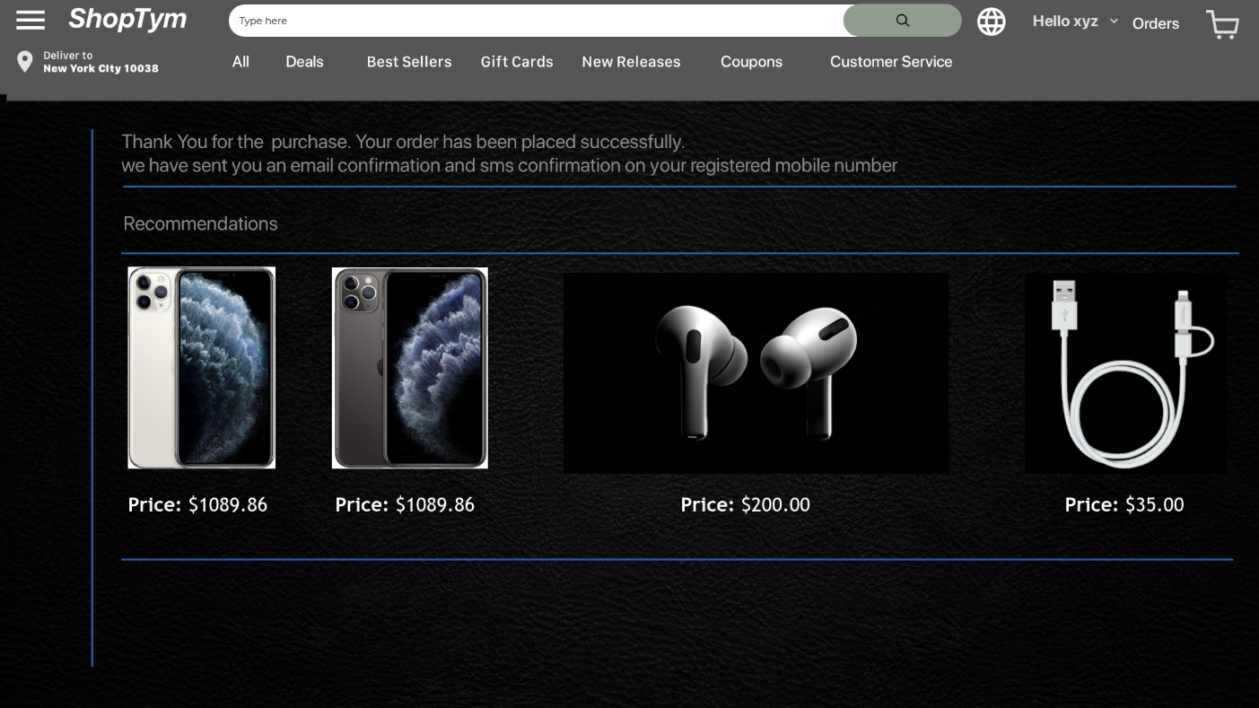

**16. System Interface Structure Diagram**

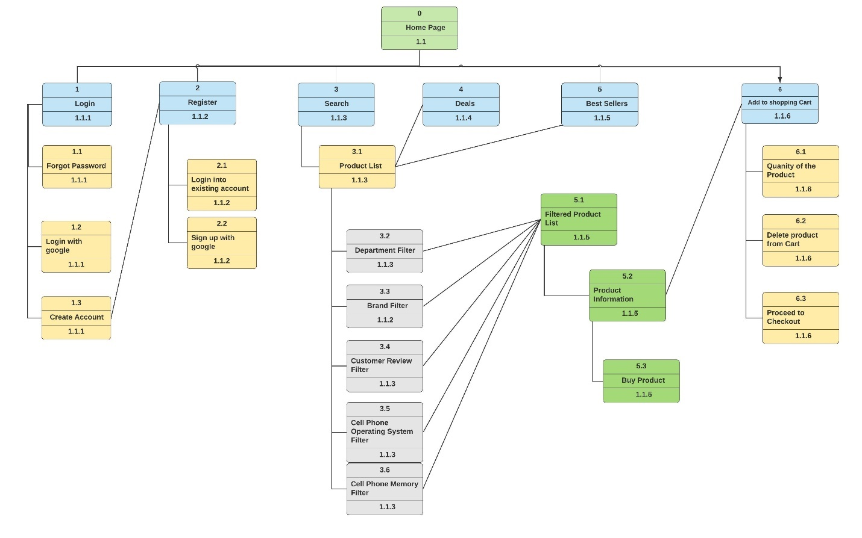

**17. Site Map**

|  |  |  |  |
| --- | --- | --- | --- |
| Account | Customer Service | Services | Deals |
| Sign In | Contact us | Purchase Products | Featured by Department |
| Sign Up | Track Orders | Search Products | Featured by Price |
| Edit personal Info | Cancel orders | Shipping Products | Featured by Customer Review |
| Recommendations | Refunds | Returning Products | Featured by Availability |
| Memberships | Customer Feedback | Filter Products | Featured by Discounts |
| Subscriptions | FAQs | Add Favorites | Featured by specifications |
| Password Recovery | Error Report | Payment Methods | Recommended products |

**18. Interface Standards**

|  |
| --- |
| **Interface Standards** |
| **Interface Metaphor:-** An E-commerce Website – ShopTym |
| **Interface Objects:-**   * **Personal Account:** System Users can view their order history, track pending orders and edit personal information like delivery addresses and mobile number. * **Search Bar:** System Users can search for products like cell phones and accessories like portable chargers, earphones and USB cables. * **Products:** Items categorized in different departments which are available for the purchase on the online platform for the customer. * **Shopping Cart:** Section that allows users to add items and eventually make the purchase. * **Filter:** Section which allows user to view relevant products and refine their search by selecting key measures to display product lists. |
| **Interface Actions:**   * **Sign up:** Register for a new account by entering personal information and creating passwords. * **Sign in:** Login into the existing account by entering user credentials. * **Modify/Manage Personal Account:** Editing personal information, changing payment method types, editing credit/debit card information, writing customer reviews, adding and deleting products from the shopping cart are performed while accessing the personal account. * **Search:** Display product lists, product price, product availability and description. * **Purchase:** Place Order for the product added in the shopping cart and proceed with the payment process. * **Payment:** Choose Payment method from the list to initiate the purchase of the product.   **Interface Icons:**   * **Webpage Icon:** ShopTym logo on Home Page, Login page, After Login Page, checkout page * **Favorites:** The user clicks on the Icon to add the product to favorites. |

**19. File and Data Specification**

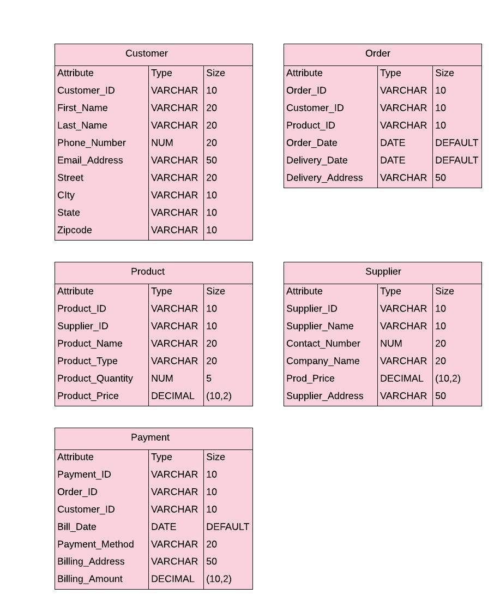

**20. Physical Data Model**

**Entity Relationship Diagram**

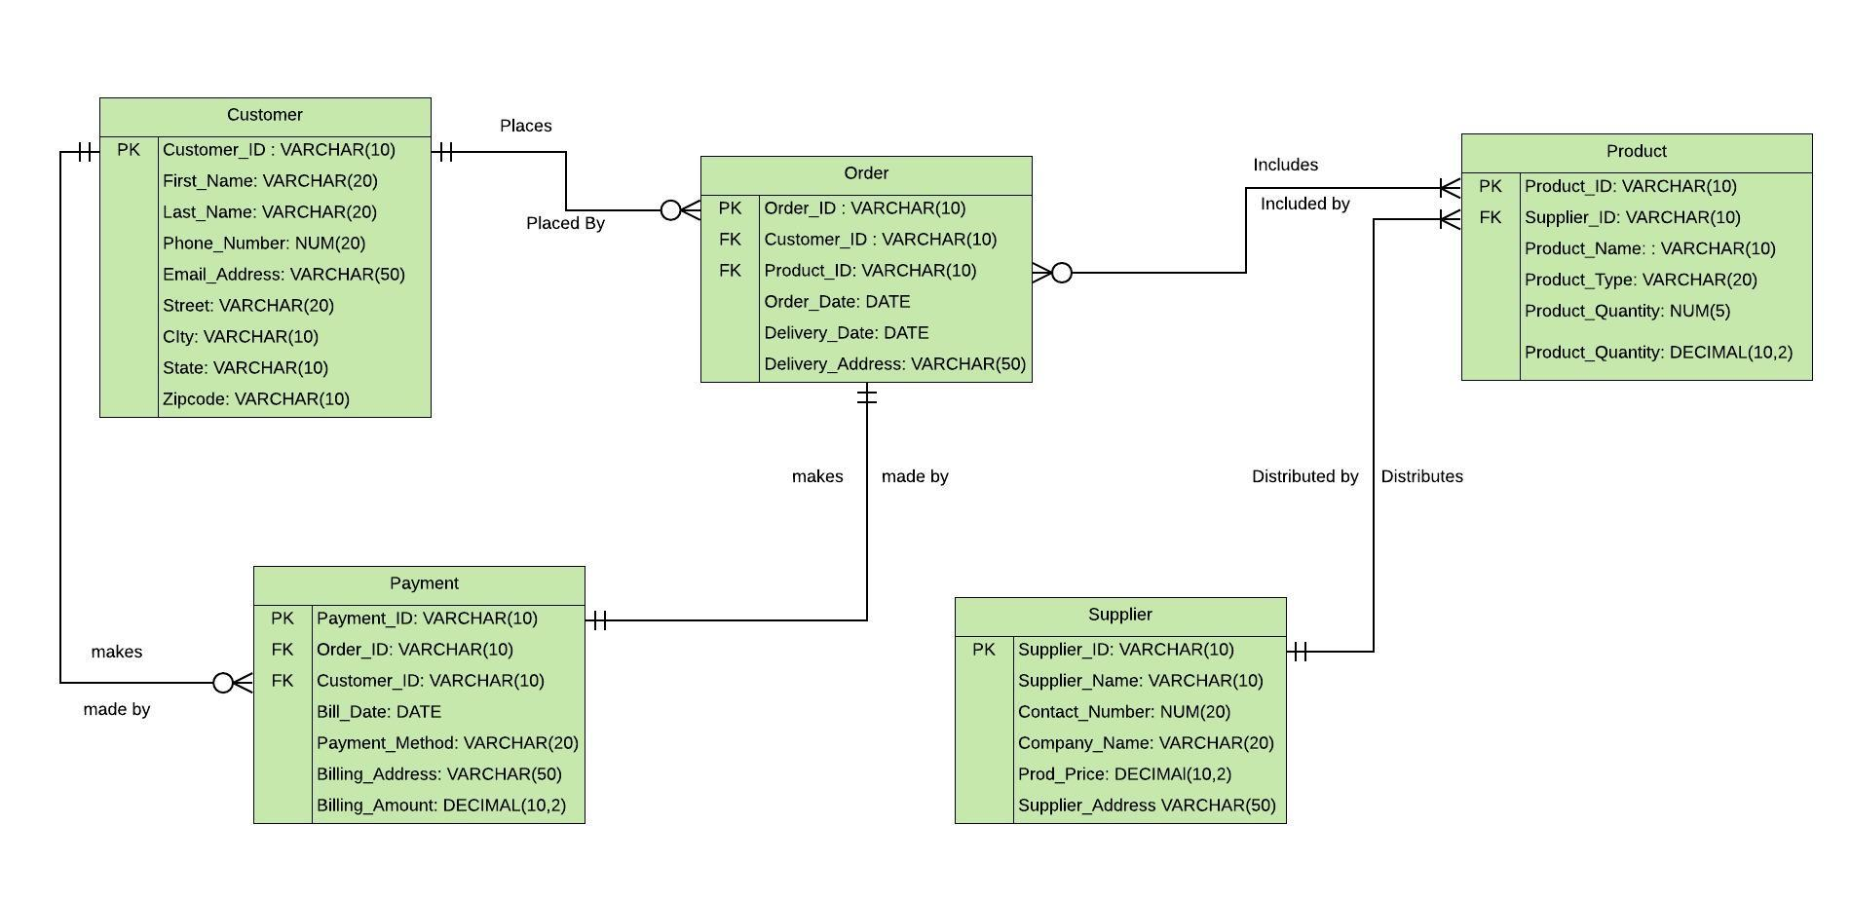

**21. Revised CRUD Matrix**

|  |  |  |  |  |  |
| --- | --- | --- | --- | --- | --- |
|  | Account Creation | Searching and Adding products to the cart. | Placing Order | Cancelling Order | Payment Processing |
| **CUSTOMER** |  |  |  |  |  |
| Customer_ID | CR |  | R | R | R |
| first_name | CRU |  | R | R | R |
| Last_name | CRUD |  | R | R | R |
| Phone_number | CRU |  | R | R | R |
| email_address | CRU |  | R | R | R |
| street | CRU |  | R | R | R |
| city | CRU |  | R | R | R |
| state | CRU |  | R | R | R |
| zip code | CRU |  | R | R | R |
| **ORDER** |  |  |  |  |  |
| order_id |  |  | CR | RD | R |
| customer_id |  |  | R | R | R |
| product_id |  |  | R | R | R |
| Order_date |  |  | C | RD |  |
| delivery_date |  |  | C | RD |  |
| delivery_address |  |  | CRU | RD |  |
| **PRODUCT** |  |  |  |  |  |
| product_ID |  | CR | R | R | R |
|  | Account Creation | Searching and Adding products to the cart. | Placing Order | Cancelling Order | Payment Processing |
| product_name |  | CR | R | R | R |
| product_type |  | CR | R | R | R |
| product_quantity |  | CRU | RU | R | R |
| product_price |  | CR | R | R | R |
| **PAYMENT** |  |  |  |  |  |
| payment_id |  |  |  | RD | CR |
| order_id |  |  |  | RD | R |
| customer_id | R |  |  | R | R |
| payment_date |  |  |  | RD | CR |
| billing_address | R |  |  | RD | RU |
| Billing_amount |  |  |  | RD | CR |

**22. Executive Summary**

The project is based on a company named Chandigarh Trading LLT and they are well distinguished business established in 1990’s. Their company basically sells mobile phones, sim cards, phone accessories such as chargers, earphones, and others. Additionally, their business has also Fed-ex hold location service, where the customers can send and receive packages. As we were interviewing, we figured out their business method is traditional and they hardly use any technology to perform their business. Due to this reason their business reach is limited and the customers have to actually visit the place in person to purchase their products or to avail their services. Along with this major problem, few minor problems were also discovered such as the company never maintained a proper digital record or a database of the products and if the customer wants to place an order without visiting then they need to call and if the representatives are not available then the business suffers loss. In order to tackle these problems we decided to develop a e-commerce platform in order to extend their business reach and allow to flourish their business by performing critical analysis of the proposed system. The website will be ubiquitous and the user can access and operate it easily and they can place an order as per their convenience. All these factors addresses to the problems mentioned above and hence we decided to pursue our decision. The process started with requirement gathering phase, in which we conducted few interviews with the owner of the business Mr. Ashwini Bansal and the employees. The purpose of these interviews were to gather the requirements for the development of the website and to understand their existing system and finally we discussed the process to develop the newer system. Once the owner’s approval was received, we then began the planning phase. In this phase, we developed system workflow diagram which basically represents the current system. System request document:- which states the business needs, business requirements, business value and special issues. This document provided the need of this project and value that it will provide to the organization and it addresses special related to the development. Feasibility assessment was performed, where technical, economic and organizational feasibility were considered. Finally Cost-benefit analysis, risk assessment and project development plan was developed. The Cost-benefit analysis allowed us to analyze the project’s total cost and break-even point. The risk assessment allowed us to identify various risks and their effect on the development of the project. Necessary steps were taken to eliminate or mitigate them. The Project work plan is performed to get the estimate duration of the project. This concludes the planning phase and the second phase begins with analysis. In this phase, the first step was to refine and revise the phase one of the project. Next step began with defining Functional as well as non-Functional requirements. Here we basically stated the major requirements which would streamline customer experience and enhance the website’s purchase funnel. The non-functional requirements were segregated into four types: Operational, Performance, Security and Cultural Requirements. Here we described the primary features to be incorporated on the online platform. We further moved on with use cases where we outlined a certain list of actions describing the interactions between an actor and the proposed system. We identified normal as well as the alternative courses of the major processes in the system. Along with that, we delineated the information for most of the actions performed by the actor and system and categorized them on the basis of inputs and outputs. The use cases were mainly used to describe the main processes and their execution. Pre-conditions, post-conditions and exceptions were covered as well additionally, summary is performed to link it with the data flow diagrams. The data flow diagrams are used popularly to represent the process models. The DFD consist of several set of rules which are needed to be followed while forming them, as they are critical during the implementation phase. The data flow diagrams were used to form the basis of entire development of the entire website. Since it will be to complex to fit an entire process into a single diagram, the data flow diagrams are divided into several level. With the increase in level, the complexity of the process increases and the level 0 represents all the process. The next step includes the development of Entity-Relationship diagrams, in which firstly the entities are identified and attributes related to main process of the system are considered. Secondly they are linked with each other through cardinality. The cardinality is used to represent the relation between the two entities. The E-R diagrams were the final component of the second phase. The Design phase begins with the revision of the analysis phase. The alternative matrix was the first step in the design phase. The alternative matrix helped us to compare the best system acquisition method based on the highest score calculated at the end of the matrix. In this matrix various factor of feasibility analysis are considered, with the acquisition types and they are scored accordingly. The final score will suggest the best method to adopt for implementation process. The non-functional requirements and CRUD matrix are refined and revised in the next stage. In the next stage we represented system specifications, which is the design of the website pages such as login page, main page, payment page and others. Additionally, we developed system’s interface structure diagrams to primarily represent path to different functionalities offered by the e-commerce website. Secondly, the interface standards were created to distinguish different actions, icons, objects and other factors available on the website. This concludes the Design phase, and the next phase is the implementation phase.

**23.** **Lessons learnt from the Project**

**1.** Understood the basic techniques and approaches incorporated in system analysis and design.

* While working for the deliverables, we understood all the phases of system development life cycle as well as the important concept of building an system with according to business needs.
* We understood most of concepts by performing tasks practically in class itself.

**2.** Keeping track of Project work and synchronizing all the assigned work

* We understood the importance of completing tasks before deadline by keeping track of all the work assigned to the project members.

**3.** Improvising deliverables

* We learnt to improvise each and every project part to achieve a stable and refined system in the final deliverable.

**4.** Understood the importance Project Meetings

* Project meets basically helped us to understand the objective of the project as well as its final outcome.
* Knowing everyone’s capabilities helped us to choose the project tasks accordingly.

**24. References**

* Book – System Analysis and Design, 6th Edition by Alan Dennis, Barbara Haley Wixom and Roberta M. Roth
* Website Design Reference – Amazon E-commerce Website - [www.amazon.com](http://www.amazon.com)
* Website Design Reference- BestBuy- [www.bestbuy.com](http://www.bestbuy.com)

**APPENDIX**

1. **Requirement Gathering Survey - Users**

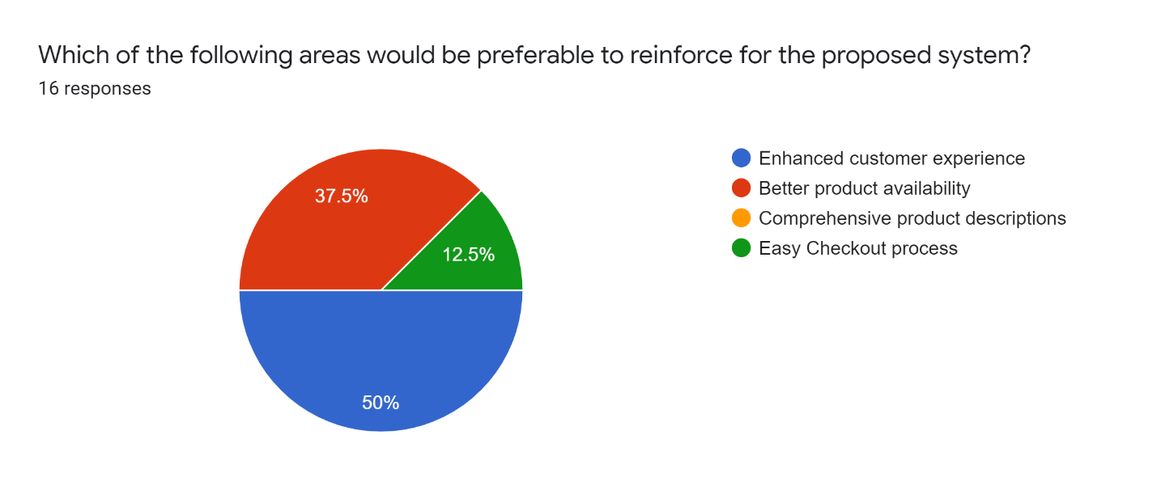

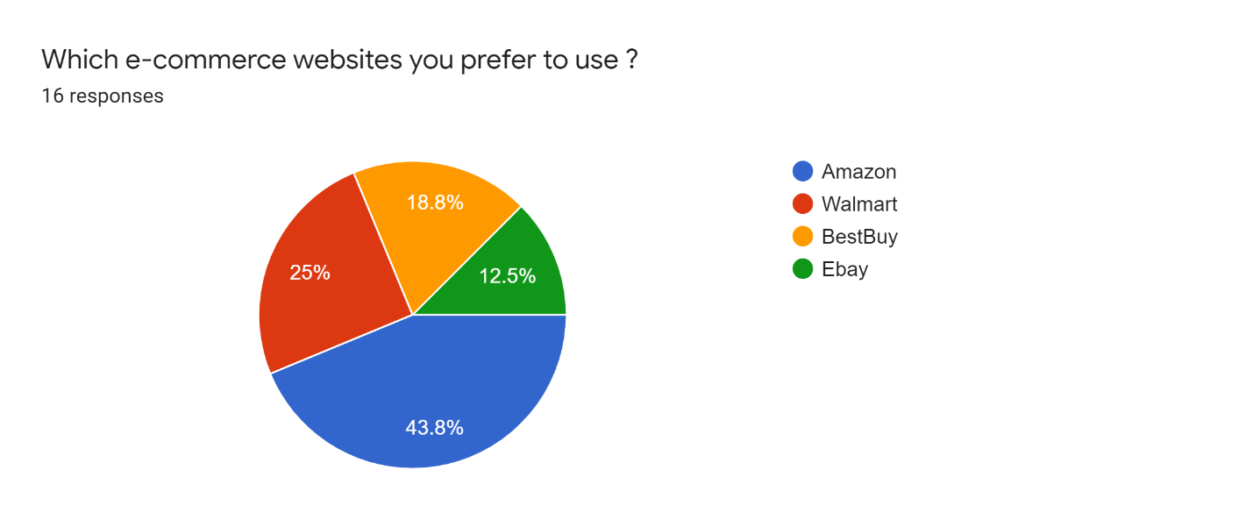

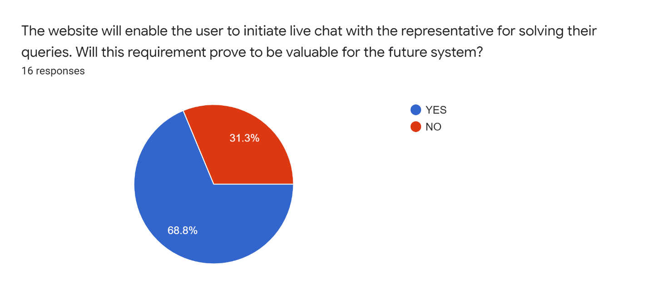

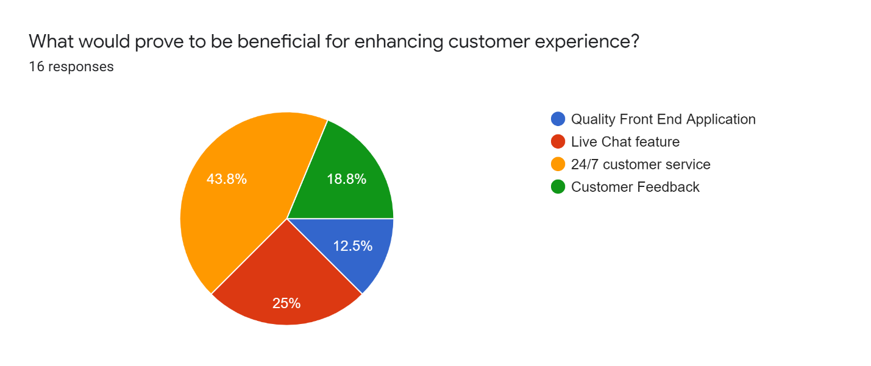

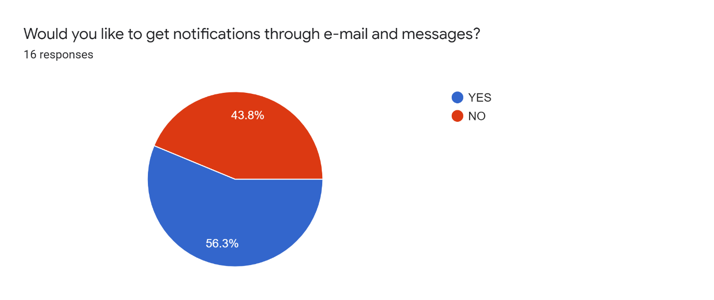

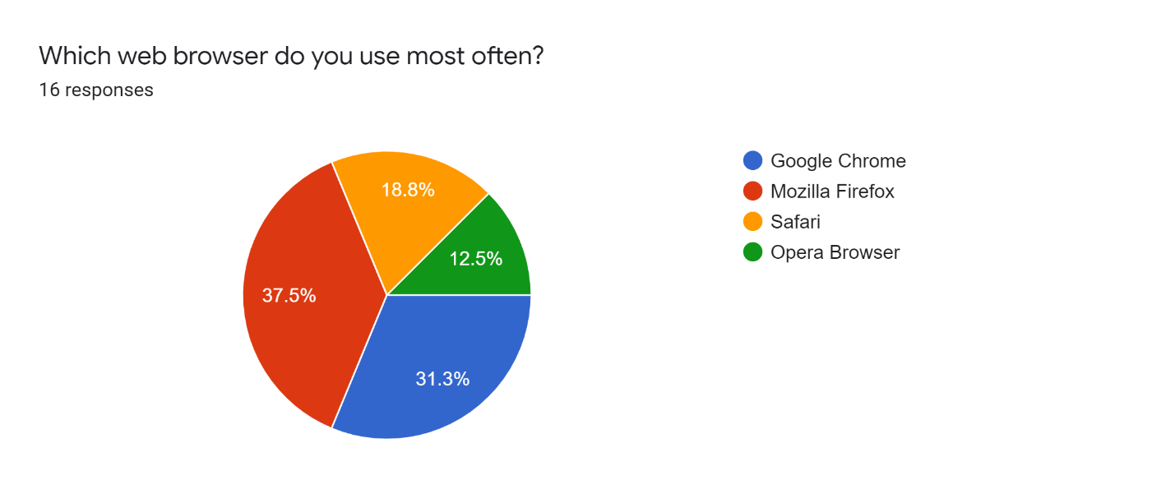

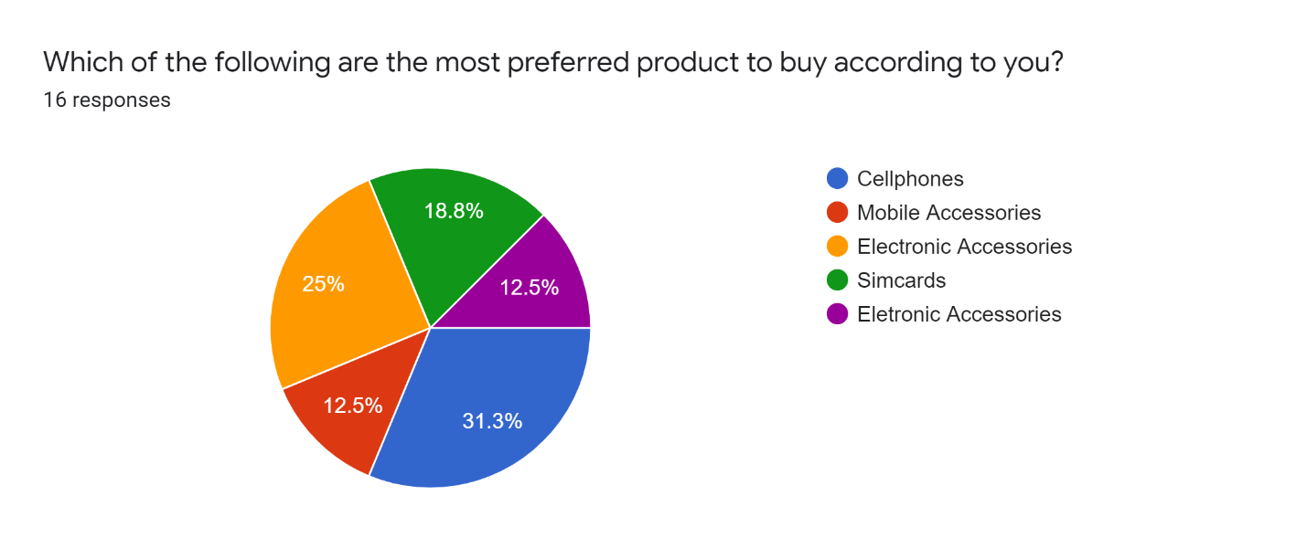

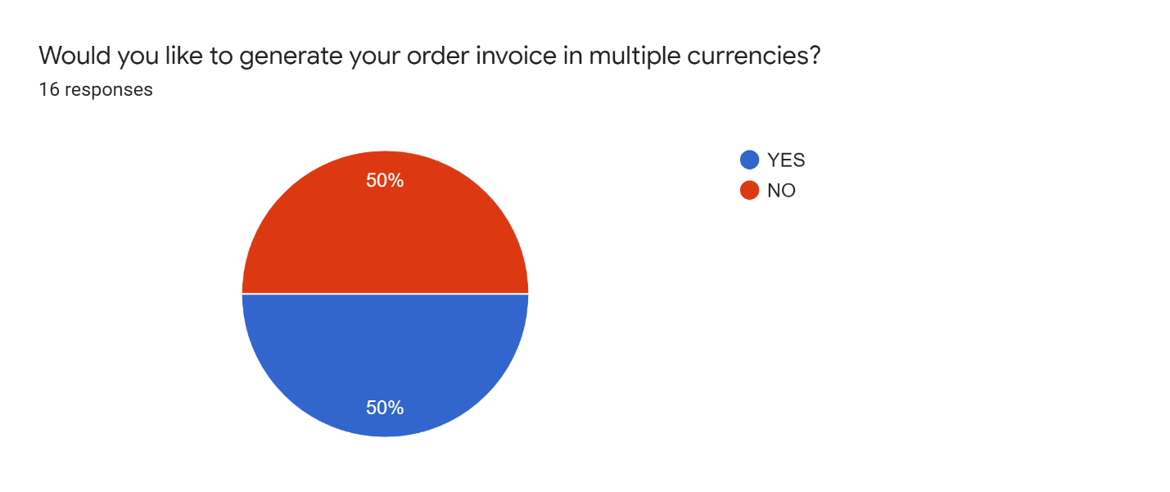

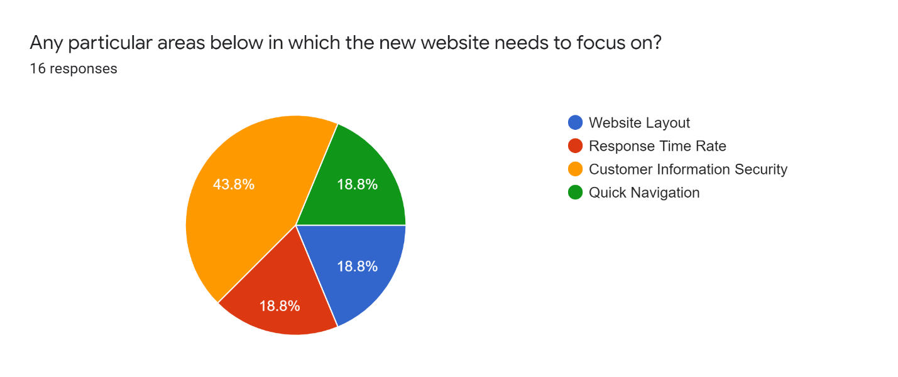

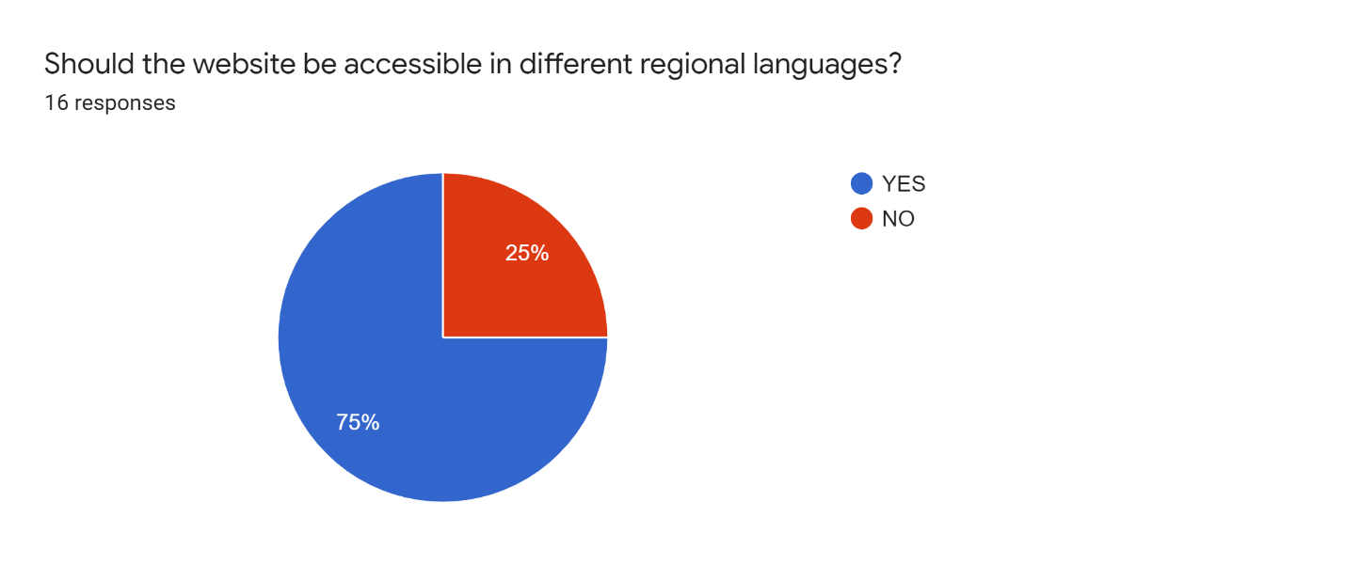



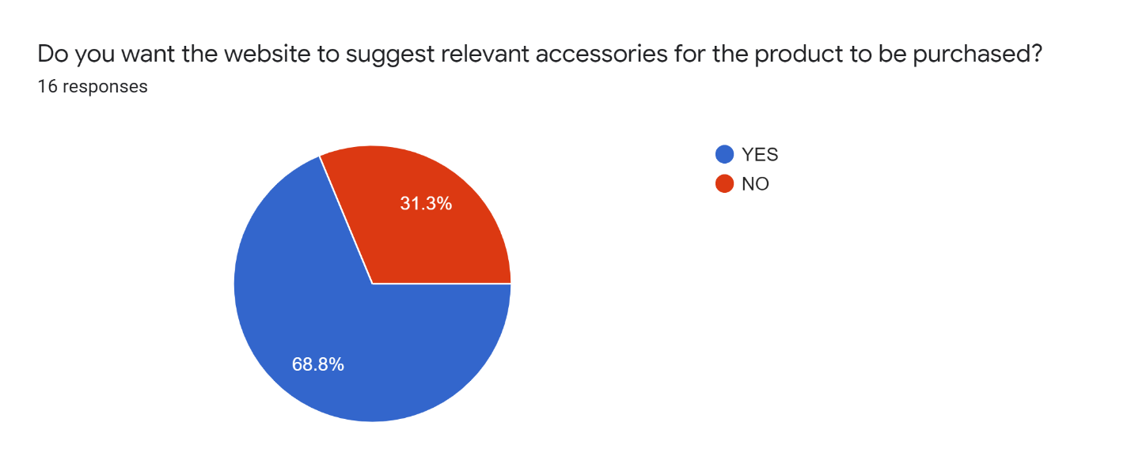

1. **Interview**

|  |  |
| --- | --- |
| **Person Interviewed:** Ashwini Bansal | **Interviewer: Team** |
| **Purpose of Interview:**   * To Identify functional and nonfunctional requirements for the future system. * To improve the customer experience by streamlining the purchase funnel of the business. * To understand the process of data storage in the existing system. * To determine the business scope of the current system and understand the steps needed to make proposed system efficient. * To reinforce the business by identifying the root cause of the issues faced in the existing process and build a productive system. | |
| **Summary of Interview:**  **Problem Identification**  The problems that we were able to identify in their existing system were:-   * The owner does not maintain a proper digital record or a database of the products he sells in his business. * The orders are accepted on calls and if the representatives are not available then the customer must wait to place their order.   **Suggested Improvements**   * A secured payment portal will be developed to protect the integrity of the user’ data. * To create a database to store the product inventory and the user’s data to further derive insights to improve business.   The most ordinary data errors found in the existing system include:   * Insufficient customer data * Product Database Deficiency | |

|  |
| --- |
| **Open Items:**   * Identifying User requirements for the proposed new system. * To understand the customer base by getting product purchase reports. * Understanding the user requirements and taking follow-up from the business owner for requirement gathering. |
| **Detailed Notes:**   * The owner expects to incorporate a separate database for storing product data and customer data on the online platform that will churn out insights to improve end to end business processes. * After assembling the products, the owner makes sure to store the products in bulk to avoid product unavailability and out of stock issues. So the priority of tracking products and their availability for the customers will be high. * The Owner expects better end to end communication with the customer and focus on customer service which will be a functional requirement for the proposed system. * The Fed- Ex hold service can also be streamlined on the online platform where the Fed-ex users will be able to track the status of their consignments and book appointments to pick up the package from the hold location. |
| Interview Notes Approved by: Mr. Ashwini Bansal |

**2.1 Interview Transcript**

**Interviewers:** Rohin Mehta, Smit Ajmera, Shivani Jain, Yi Xie, Karan Patel,

**Interviewee:** Mr. Ashwini Bansal (Founder & CEO of Chandigarh LLT)

**Interview Date:** 10/15/2019

**Interview:-**

**Interviewer:** Hello Sir, Good Evening.

**Interviewee:** Good Evening! How are you?

**Interviewer:** I am doing good. Thankyou. You are already familiar with our academic project. We are conducting this interview to determine requirements and specific features for our proposed new system.

**Interviewee:** Oh Great! How may I help you with this?

**Interviewer:** As you know we are building an e-commerce website for your business. So any specific requirements you would like to incorporate on the website?

**Interviewee:** Yeah Sure. I feel the website should comprise of a link for Fed-ex hold packages, where the user should be able to confirm the status of their packages and book an appointment to pick up the packages. Moreover, designing of database will help to keep track of customer information and maintain a proper digital record of products as well.

**Interviewer:** Okay. What type of payment methods would you recommend to include in the website?

**Interviewee:** I think the payment portal should include credit, debit, online wallets such as PayPal, google pay, apple pay and along with that cash on delivery to give flexibility to the customers.

**Interviewer:** Okay. Any specific difficulties you would like to address in your current system?

**Interviewee:** Keeping track of customers is a challenge as the orders are accepted on calls and if the representatives are not available then the customer must wait to place their order to be accepted by them.

**Interviewer:** Yeah That must be tough job to do.So how do you overcome this for strengthening your customer base?

**Interviewee:** I promote my products through advertisements and visual merchandising by displaying products by category in an organized frame and incorporate interactive displays in the store to engage customers to buy the product.

**Interviewer:** All right! I would like know any other requirements that you feel should be included in the new system?

**Interviewee:** Yeah. There are few of them. I think you can allow the website to generate invoice in multiple currencies. Along with that, you can design the website such that it will adapt to the language set by the respective machine of the user. One more thing you can add is that the website should offer multiple mediums to understand customer requirements and know their feedback and give priority to their reviews for the product.

**Interviewer:** That’s good to hear. Okay, so what are your expectations from the new system?

**Interviewee:** I am expecting that you’re going to design a productive system and focus on its purchase funnel to enhance customer experience. I also expect you to create a database for the website which will help to track products availability, customer’s favored products, customer information and sales.

**Interviewer:** Yeah sure sir. We are trying our best to get the appropriate outcomes for the project and receive positive result.

**Interviewee:** Nice!

**Interviewer:** Okay Sir, Any other areas in which you would like for us to address for the project?

**Interviewee:** Nope. Everything is good to go for the project. Any other questions for me?

**Interviewer:** No sir. That will be enough for today.

**Interviewee:** It was great interacting with you guys! All the best for the project.

**Interviewer:** Thank you for your time sir. We will update you if we need anything for further process.

**Interviewee:** Yeah definitely! Goodbye. Take care.

**Interviewer:** Goodbye!

1. **Project Discussions – Deliverable 1**

**Meeting 1**

**Date of the Meeting:** 9/19/2019

**Start Time:** 15:30 PM

**End Time:** 17:30 PM

**Present Group Members:** Rohin Mehta, Smit Ajmera, Yi Xie, Karan Patel, Shivani Jain

**Discussion Report:**

* Finding the organization for new system design.
* Discussed about the information needed for the project proposal.
* Discussed about questions needed to ask to organization employees about the existing system.
* Discussing the approach Top -down

**Meeting 2**

**Date of the Meeting:** 9/23/2019

**Start time:** 16:00 PM

**End Time:** 17:30 PM

**Present Group Members:** Smit Ajmera, Rohin Mehta, Yi Xie, Shivani Jain

**Discussion Report:**

* Understanding the functionality of the existing system and proposed new system.
* Discussion about process of Planning phase of the system.
* Assignment of tasks to all members for the deliverable 1.

**Meeting 3**

**Date of the Meeting:** 9/27/2019

**Start Time:** 17:30 PM

**End Time:** 18.45 PM

**Present Group Members:** Rohin Mehta, Smit Ajmera, Yi Xie , Shivani Jain

**Discussion Report:**

* To take follow up the of the tasks assigned to the project members and track the deliverable 1 report.
* Verifying the information submitted by group members.

**Meeting 4**

**Date of the Meeting:** 1/1/2019

**Start Time:** 14.00 PM

**End Time:** 18.30 PM

**Present Group Members:** Rohin Mehta, Smit Ajmera, Shivani Jain, Karan Patel

**Discussion Report:**

* To prepare final draft of the project report and assemble the necessary documents.
* To verify if any part gets missed out and begin the process of deliverable 2.

**4. Project Discussions – Deliverable 2**

**Meeting 1**

**Date of the Meeting:** 10/10/2019

**Start Time:** 15:00 PM

**End Time:** 17:00 PM

**Present Group Members:** Rohin Mehta, Smit Ajmera, Yi Xie, Karan Patel, Shivani Jain

**Discussion Report:**

* Revising the first deliverable to make appropriate changes.
* Assigning of tasks to all team members for the deliverable 2.

**Meeting 2**

**Date of the Meeting:** 10/14/2019

**Start time:** 16:00 PM

**End Time:** 17:30 PM

**Present Group Members:** Smit Ajmera, Rohin Mehta, Yi Xie, Shivani Jain, Karan Patel

**Discussion Report:**

* Understanding the Analysis Phase and its outcomes.
* Understanding the functional and nonfunctional requirements of the new system.

**Meeting 3**

**Date of the Meeting:** 10/15/2019

**Start time:** 17:00 PM

**End Time:** 18:00 PM

**Present Group Members:** Smit Ajmera, Rohin Mehta, Yi Xie, Shivani Jain, Karan patel

**Discussion Report:**

* Conducting Interview.
* Conducting Survey.
* Understanding the business processes to understand use cases.

**Meeting 4**

**Date of the Meeting:** 10/20/2019

**Start time:** 12:00 PM

**End Time:** 14:00 PM

**Present Group Members:** Smit Ajmera, Rohin Mehta, Yi Xie, Shivani Jain

**Discussion Report:**

* Discussion about developing process models.
* Getting started with designing Process models.

**Meeting 5**

**Date of the Meeting:** 10/29/2019

**Start time:** 15:00 PM

**End Time:** 17:30 PM

**Present Group Members:** Smit Ajmera, Rohin Mehta, Yi Xie, Shivani Jain

**Discussion Report:**

* Understanding Data Modelling for organizing data.
* Developing E-R Diagram.

**5. Project Discussions – Deliverable 3**

**Meeting 1**

**Date of the Meeting:** 11/29/2019

**Start Time:** 15:30 PM

**End Time:** 17:00 PM

**Present Group Members:** Rohin Mehta, Smit Ajmera, Yi Xie, Karan Patel, Shivani Jain

**Discussion Report:**

* Revising the second deliverable
* Assigning of tasks to all team members for the deliverable 3.

**Meeting 2**

**Date of the Meeting:** 12/2/2019

**Start time:** 14:00 PM

**End Time:** 16:30 PM

**Present Group Members:** Smit Ajmera, Rohin Mehta, Yi Xie, Shivani Jain, Karan Patel

**Discussion Report:**

* Understanding the Design Phase and its outcomes.
* Revising the business requirements of the system.

**Meeting 3**

**Date of the Meeting:** 12/7/2019

**Start time:** 16:00 PM

**End Time:** 17:30 PM

**Present Group Members:** Smit Ajmera, Rohin Mehta, Yi Xie, Shivani Jain, Karan patel

**Discussion Report:**

* Developing the Revised ER Model
* Developing Alternative Matrix
* Keeping track of project tasks assigned to every members.

**Meeting 4**

**Date of the Meeting:** 12/14/2019

**Start time:** 14:00 PM

**End Time:** 18:00 PM

**Present Group Members:** Smit Ajmera, Rohin Mehta, Yi Xie, Shivani Jain, Karan Patel

**Discussion Report:**

* Discussion about Developing user Interface for the system.
* Preparing executive summary and lessons learnt in the project.